

OCTO-DE Benefit Tools Crew | Accredited Representation Management

February 24, 2025 | Appoint a Representative

Version 2.0

Revision History

|  |  |  |  |
| --- | --- | --- | --- |
| Date | Version | Description | Author |
| 12/26/2024 | 1.0 | Product Debut: Completing a 21-22 or 21-22a form online, for PDF download | Lindsay Li-Smith |
| 2/24/2025 | 2.0 | Pilot launch: Allowing LOA3 Veterans to submit a 21-22 online, for representatives that accept online submissions | Lindsay Li-Smith |

Table of Contents

1. Product Overview 4

2. User Access 4

2.1 PDF Generation of 21-22 or 21-22a Forms 4

2.2 Online Submission of 21-22 Form Only (not the 21-22a) 4

3. Navigation 5

3.1 Landing Page 5

3.2 Product Page 5

3.3 Search 5

4. Functionality 6

4.1 Introduction 6

4.2 Tell us who you are 8

4.3 Accredited representative information 8

4.4 Claimant Information 12

4.5 Veteran Information 14

4.6 Accredited representative authorizations 17

4.7 Review 20

4.8 PDF Generation Pathway: Download (Confirmation) + Next Steps 21

4.9 Online Submission Pathway: Confirmation 23

5. Major Issues and Error Messages 24

5.1 Accredited representative information 24

5.2 Review 25

## 1. Product Overview

The Appoint a Representative product is a user-friendly, accessible tool to complete VA Forms [21-22](https://www.vba.va.gov/pubs/forms/VBA-21-22-ARE.pdf) or [21-22a form](https://www.vba.va.gov/pubs/forms/vba-21-22a-are.pdf), with the ultimate goal of appointing an accredited VSO (VA Form 21-22), or an accredited attorney or claims agent (VA Form 21-22a). This experience is intended to mirror the search functionality of the older, external tool [eBenefits](https://www.ebenefits.va.gov/ebenefits/vso-search).

Users will be able to:

1. Select the representative they would like to appoint
2. Enter in their information (and the associated Veteran’s information, if the user is a non-Veteran)
3. Respond to authorizations required by the form
4. Review their input
5. Complete the form experience
   1. For most, a pre-filled form PDF will be generated for a user to download, sign and mail/bring to the representative.
   2. For LOA3 Veterans, who select an eligible representative, a 21-22 form will be submitted online. Currently the **Connecticut Department of Affairs** VSO and associated VSO representatives are the only entities available for online submission.

## 2. User Access

### 2.1 PDF Generation of 21-22 or 21-22a Forms

All users will have access to the Appoint a Representative product, that ends in PDF generation.

Authenticated users (any level) will have the benefit of:

1. Being able to save their in-progress form and revisit it later.
2. Being able to see if they have existing representation that this process will replace with new representation.
3. Having the text inputs pre-populated, based on their VA.gov Profile information.

### 2.2 Online Submission of 21-22 Form Only (not the 21-22a)

LOA3 authenticated Veteran users will be able to submit a 21-22 form online, for representatives eligible for accepting online submissions.

Currently the **Connecticut Department of Affairs** VSO and associated VSO representatives are the only entities available for online submission.

## 3. Navigation

### 3.1 Landing Page

There will be multiple pages on VA.gov that point to our landing page “Get help from a VA accredited representative” – the URL for this landing page will be <http://va.gov/get-help-from-accredited-representative>.

### 3.2 Product Page

The landing page will link to our Appoint a Representative product, which will have a URL of <http://va.gov/get-help-from-accredited-representative/appoint-rep>

### 3.3 Search

Users will also be able to find our Appoint a Representative tool through the VA.gov search.

Key terms related to this tool include: accredited, representative, representation, power of attorney, POA, attorney, claims agent, VSO, veteran service organization, VSO representative, VSO rep, veterans service officer, service organization representative, 21-22, 2122, 21-22a, 2122a, and claims support.

## 4. Functionality

Each screen in the Appoint a Representative experience has its own URL, however these can only be accessed if a user steps through the experience in order, starting at the Introduction page. Trying to access the URL directly will bring up a “Sorry, not found” error.

### 4.1 Introduction

The **unauthenticated experience** will have alerts at the top and bottom of the page, encouraging users to sign in. In the bottom alert, there is a link “Start your form without signing in” allowing users to continue without signing in.

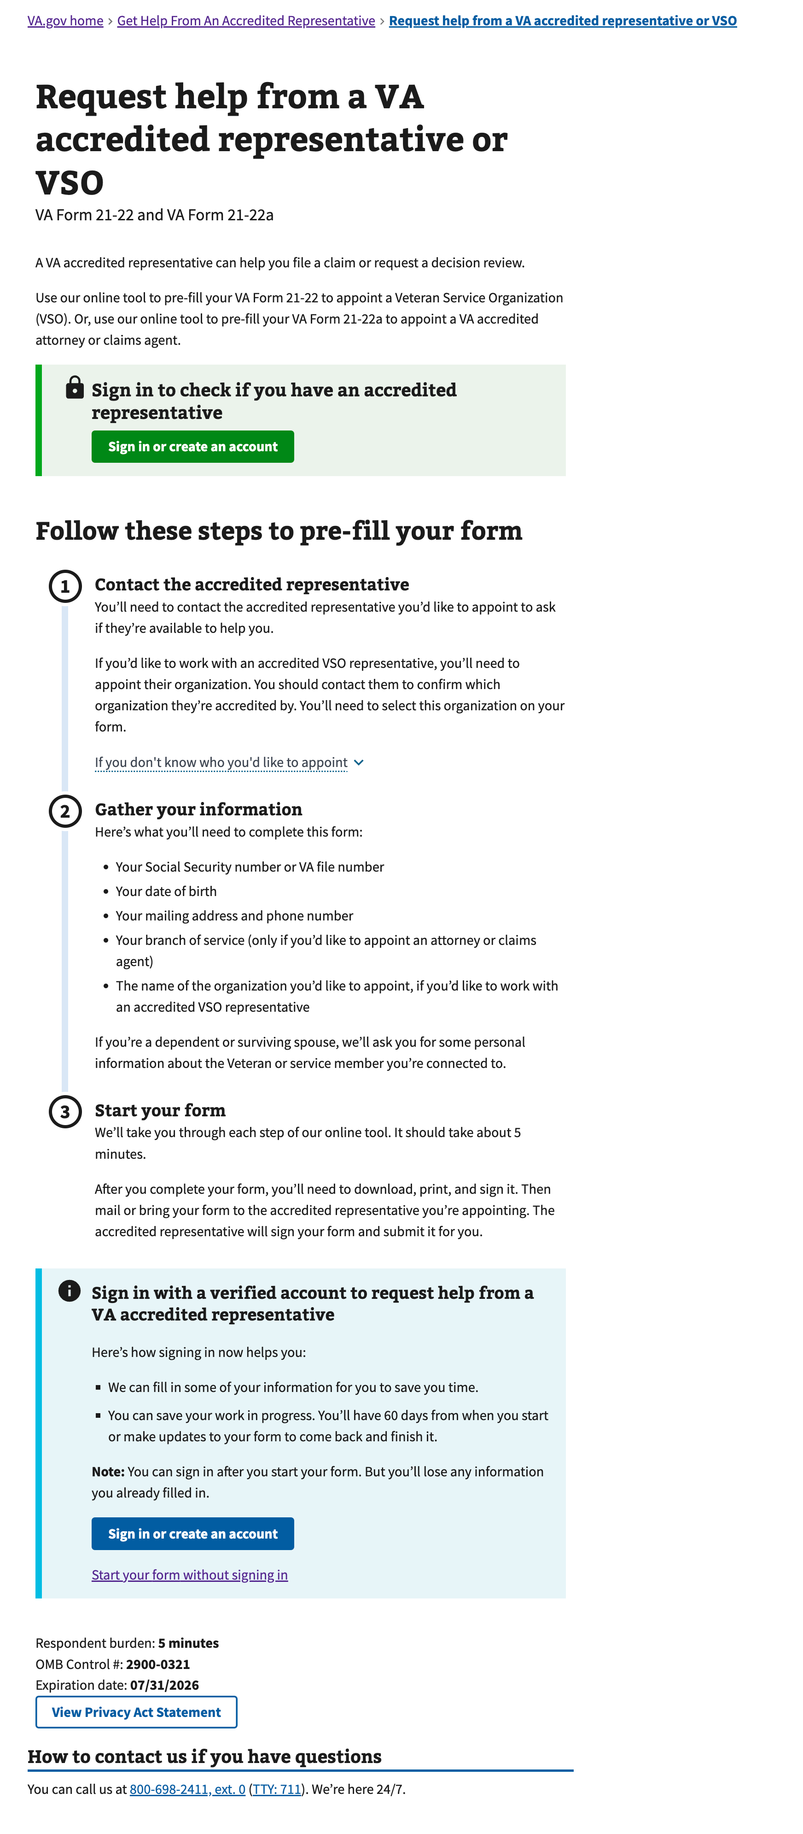

Figure 1: <https://www.va.gov/get-help-from-accredited-representative/appoint-rep/introduction> (unauthenticated)

The **authenticated experience** will show any existing representation (in the [Representative Status Widget](https://github.com/department-of-veterans-affairs/va.gov-team/tree/master/products/accredited-representation-management/product-documentation/representative-status-widget/contact-center) at the top of the page) and will have a more direct call to action “Fill out your form to request help” since a sign in prompt is not needed (they’re already signed in).

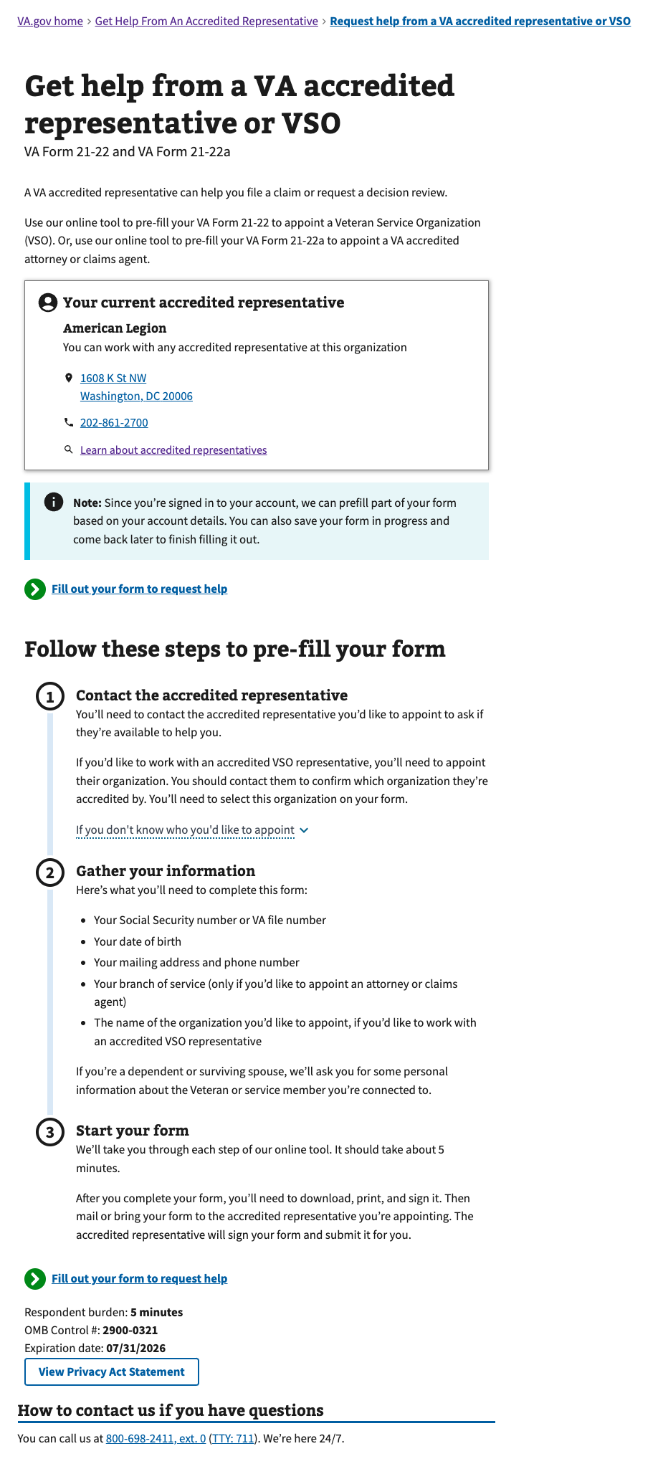

Figure 2 <https://www.va.gov/get-help-from-accredited-representative/appoint-rep/introduction> (authenticated)

### 4.2 Tell us who you are

The user must indicate if they are the Veteran. If they are not the Veteran, this form experience will request their information as the claimant, in addition to the information of the Veteran they’re connected to.

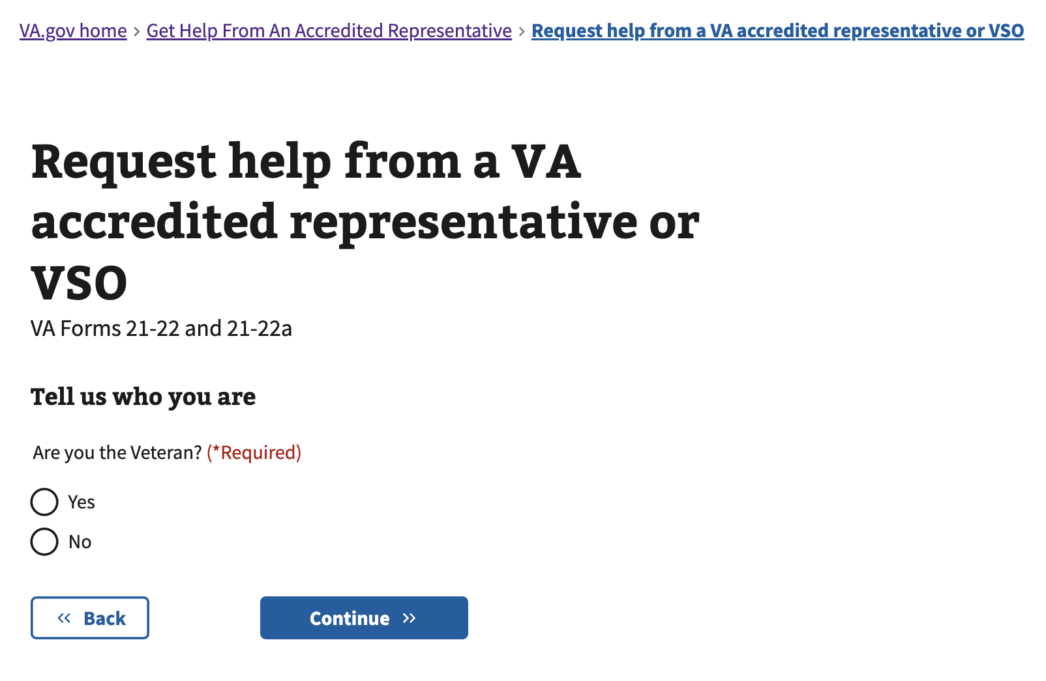

Figure 3: <https://www.va.gov/get-help-from-accredited-representative/appoint-rep/claimant-type>

### 4.3 Accredited representative information

Search for the representative’s name. If the user has not yet determined which representative to work with, they can use the “Find a VA accredited representative or VSO” link at the bottom which routes to the [Find a Representative product](https://github.com/department-of-veterans-affairs/va.gov-team/tree/master/products/accredited-representation-management/product-documentation/find-a-representative/contact-center).

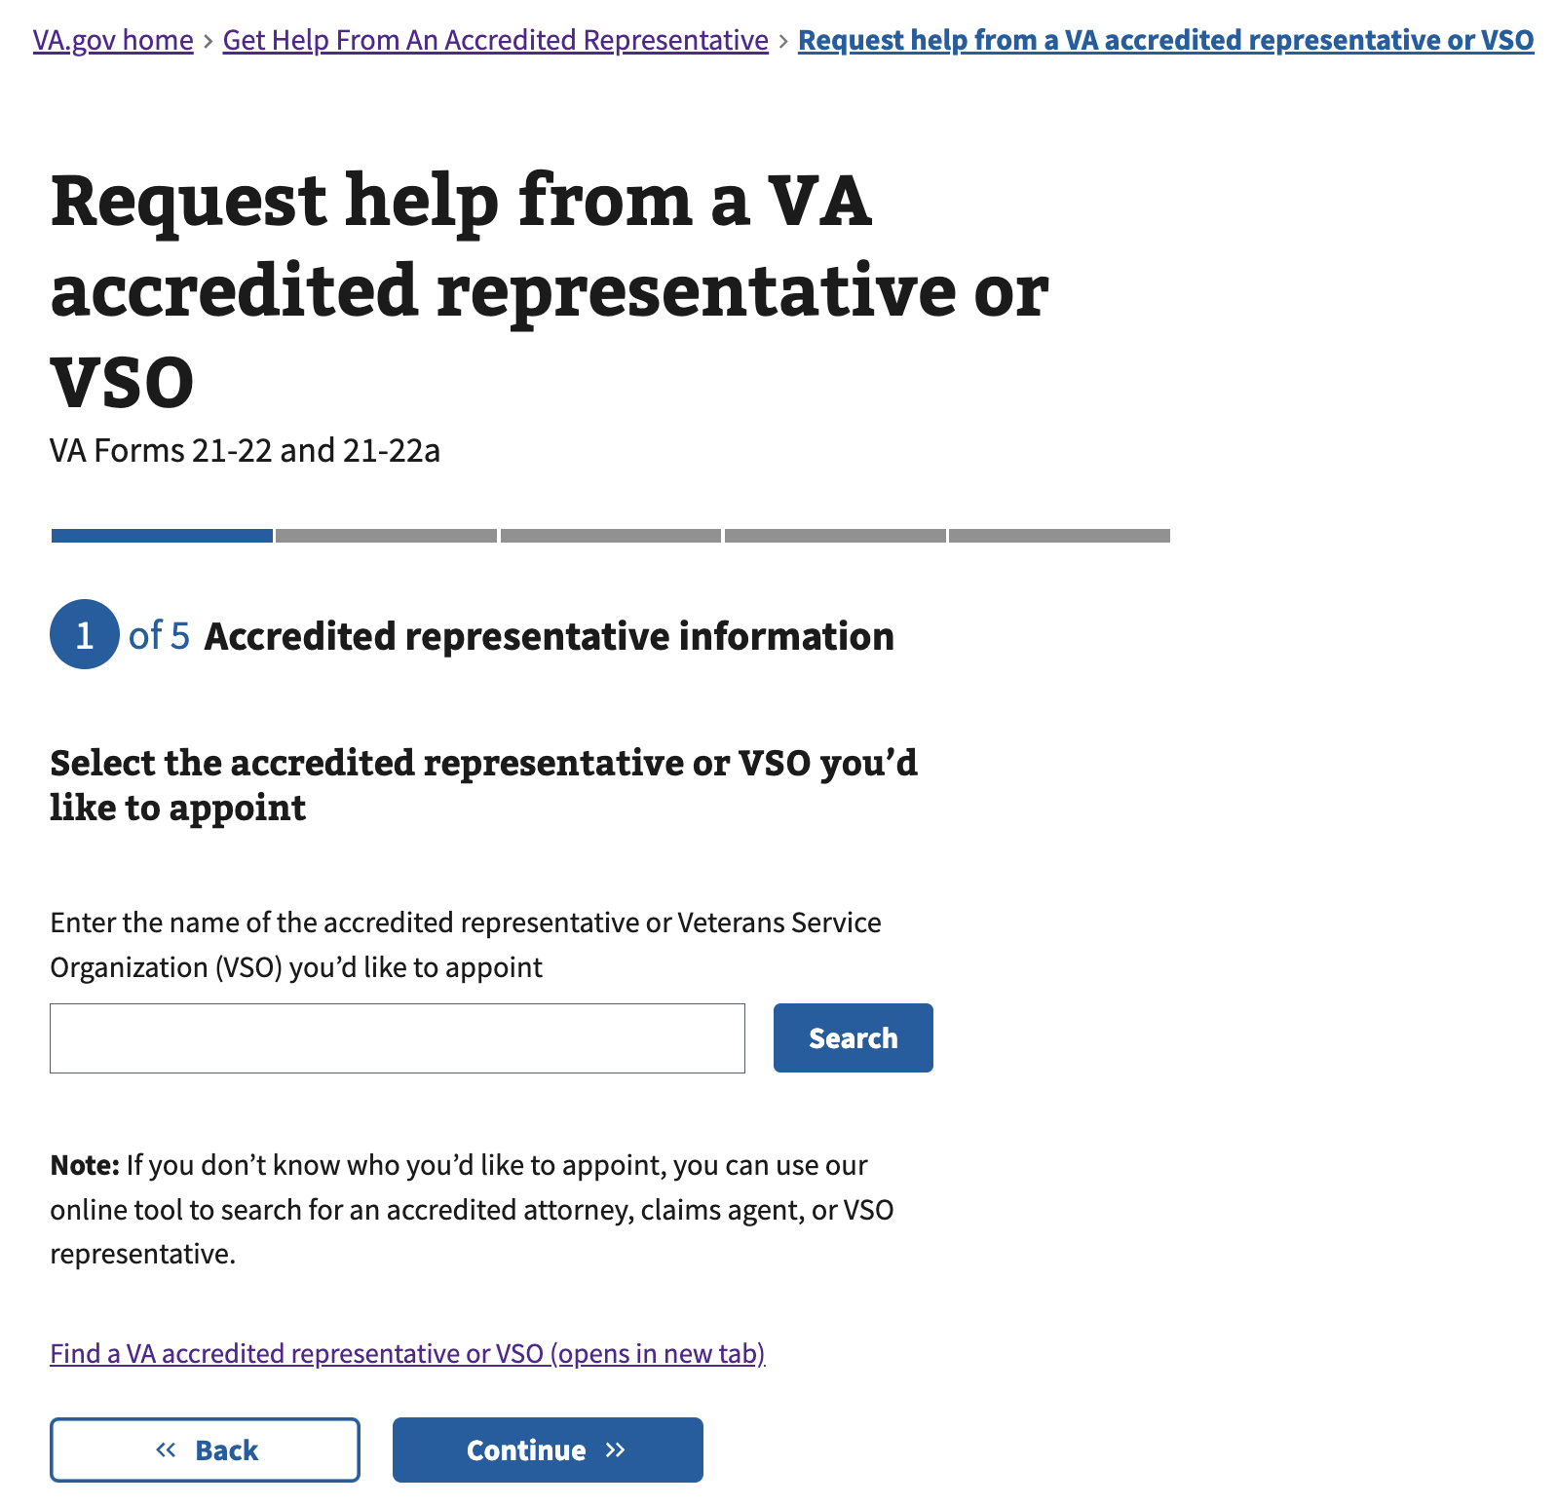

Figure 4: <https://www.va.gov/get-help-from-accredited-representative/appoint-rep/representative-select>

The user is encouraged to contact the accredited representative before proceeding further, to ensure the representative is available to help. Appointing a VSO or VSO representative will begin the VA Form 21-22 experience, and appointing an attorney or claims agent will begin the VA Form 21-22a experience.

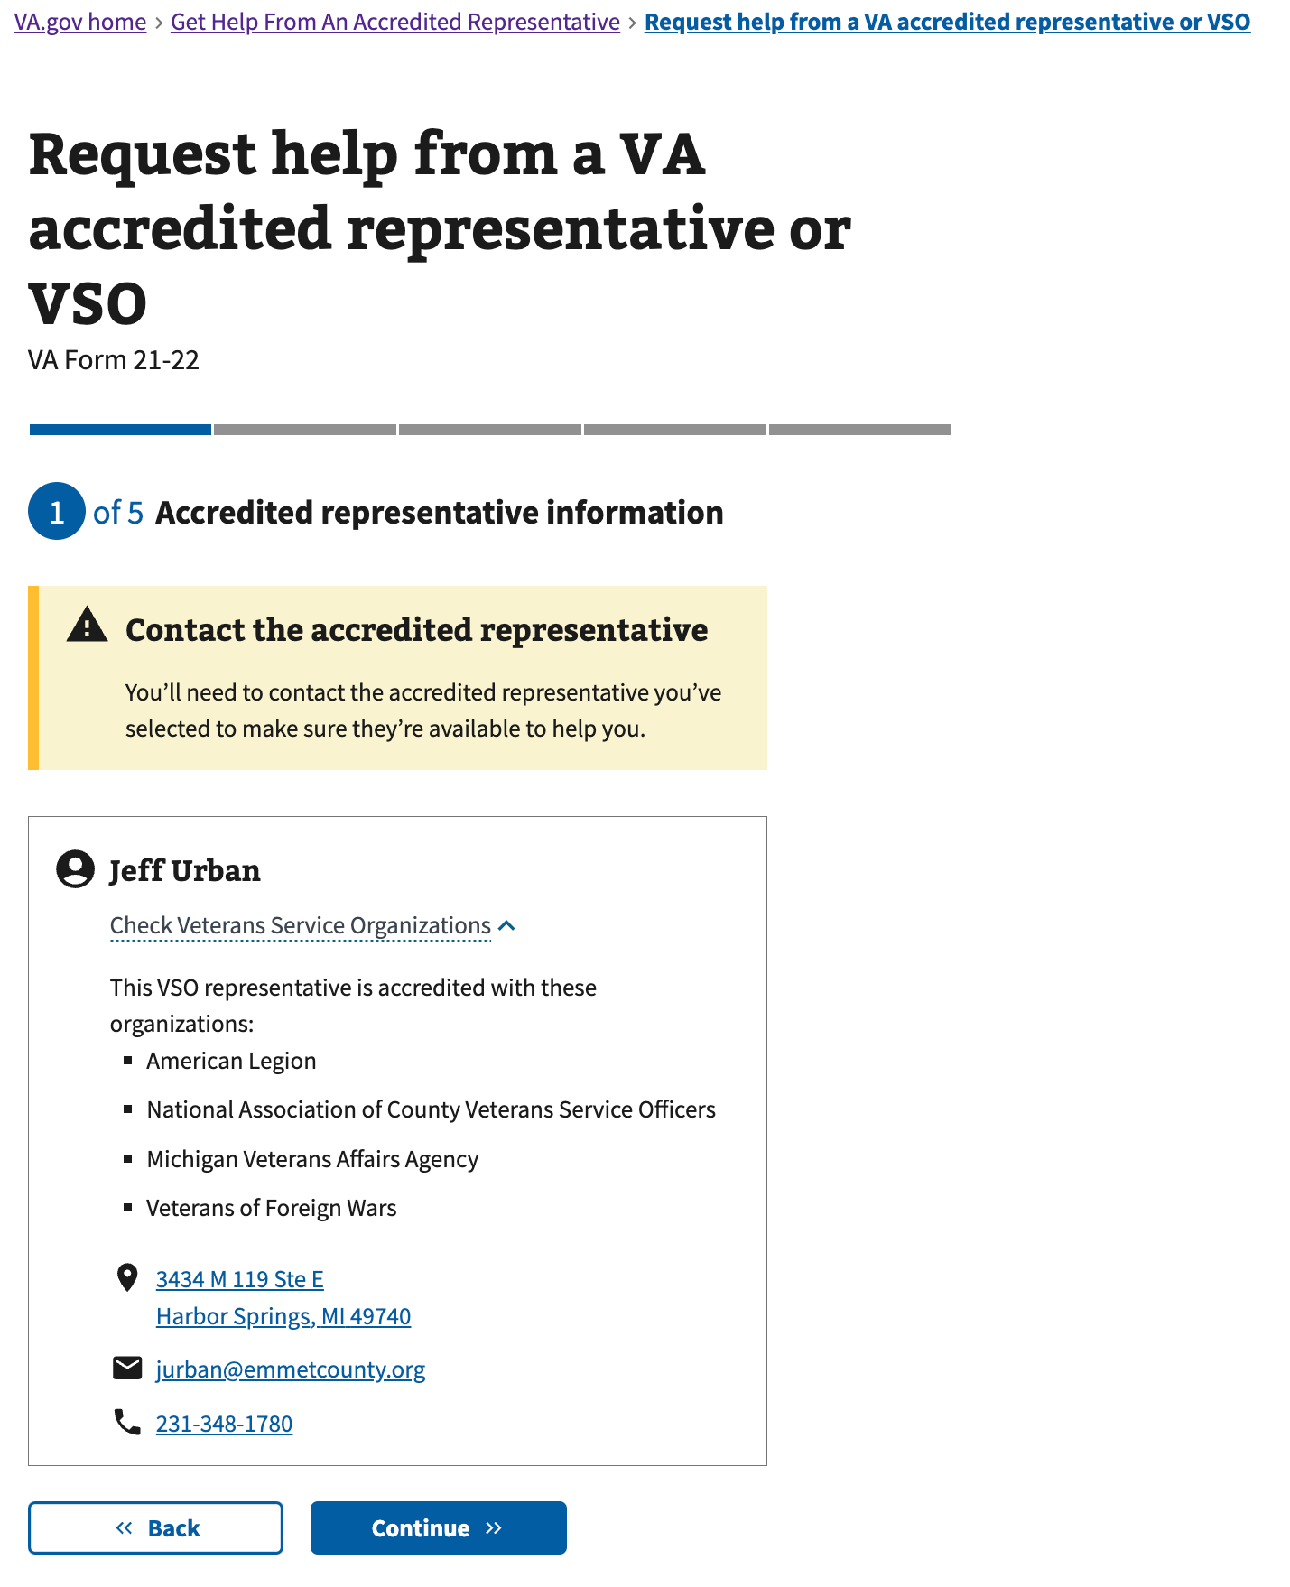

Figure 5: <https://www.va.gov/get-help-from-accredited-representative/appoint-rep/representative-contact>

If an LOA3 authenticated Veteran selects a representative that supports online submission, they will be asked how they’d like to submit their request. If “Online” is selected, the Appoint experience will end in online submission. If “By mail” or “In person” is selected, the Appoint experience will end in a generated PDF for the user to download, sign, and mail/bring to the representative.

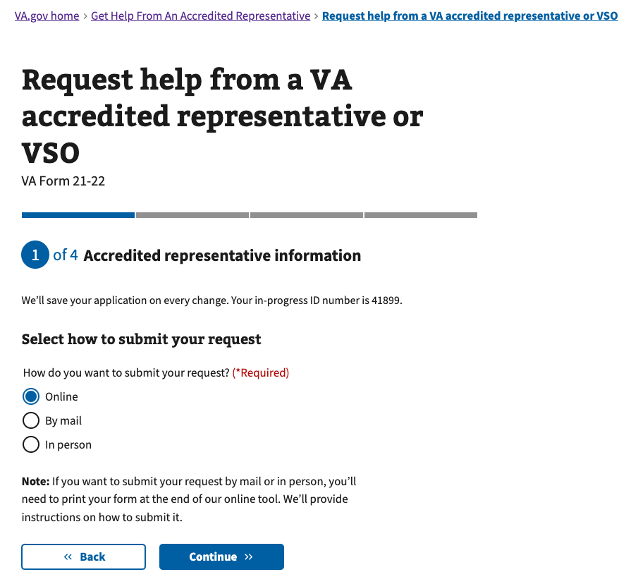

Figure 6: <https://www.va.gov/get-help-from-accredited-representative/appoint-rep/representative-submission-method>

If a VSO representative is accredited with multiple VSOs, the user will need to select which organization they’d like to appoint. This choice is completely up to the user, and they may want to discuss options with the representative to learn more about each organization.

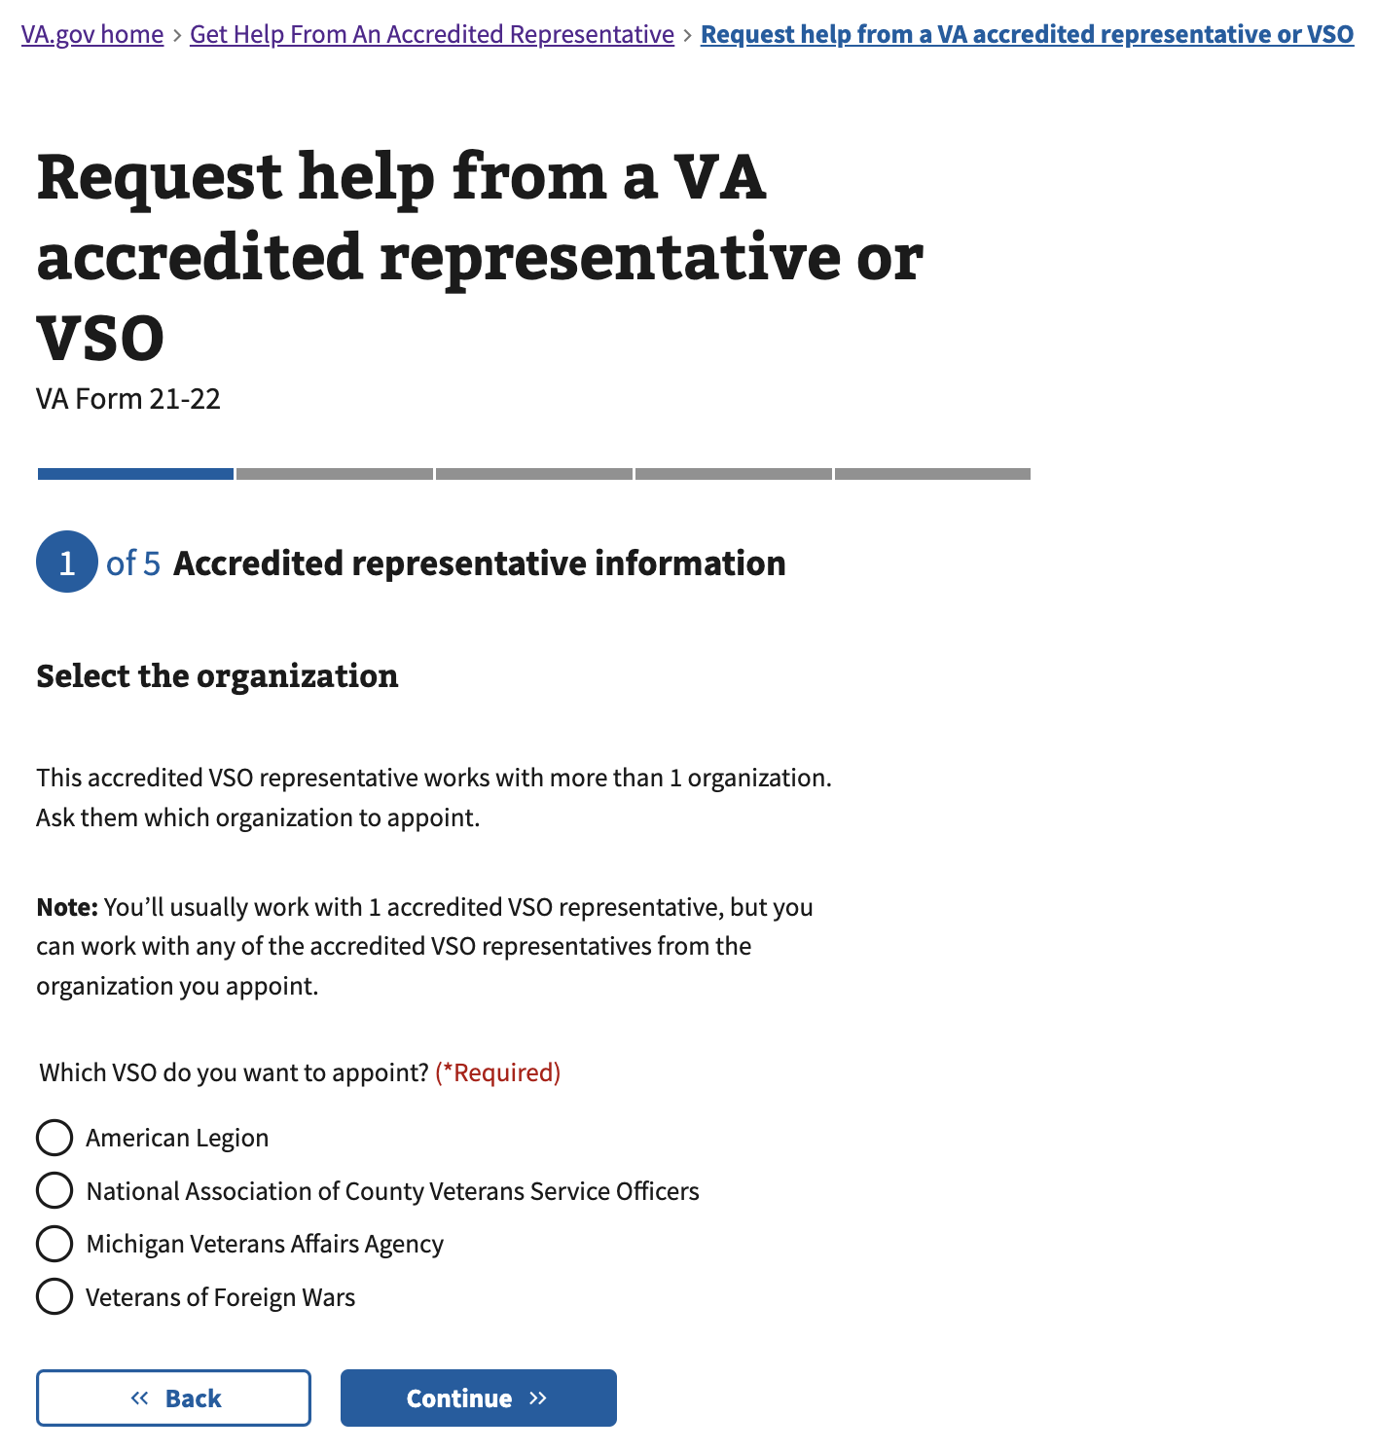

Figure 7: <https://www.va.gov/get-help-from-accredited-representative/appoint-rep/representative-organization>

(**Authenticated** users only)

If the user has existing representation, they will be alerted that appointing this new representative will replace their existing representative.

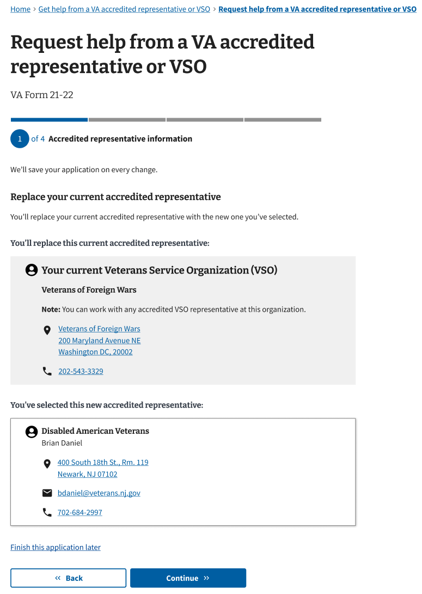

Figure 8: <https://www.va.gov/get-help-from-accredited-representative/appoint-rep/representative-replace>

### 4.4 Claimant Information

If the user indicated at the start of the experience that they are not the Veteran, the experience will request their non-Veteran claimant information at this time.

The following Claimant Information screens show the **unauthenticated** experience**.** Authenticated users will have the inputs pre-populated based on information in their VA.gov Profile; changes will only affect this application and the VA.gov Profile will not be updated. (See the Veteran Information section below, for an example of content for authenticated users.)

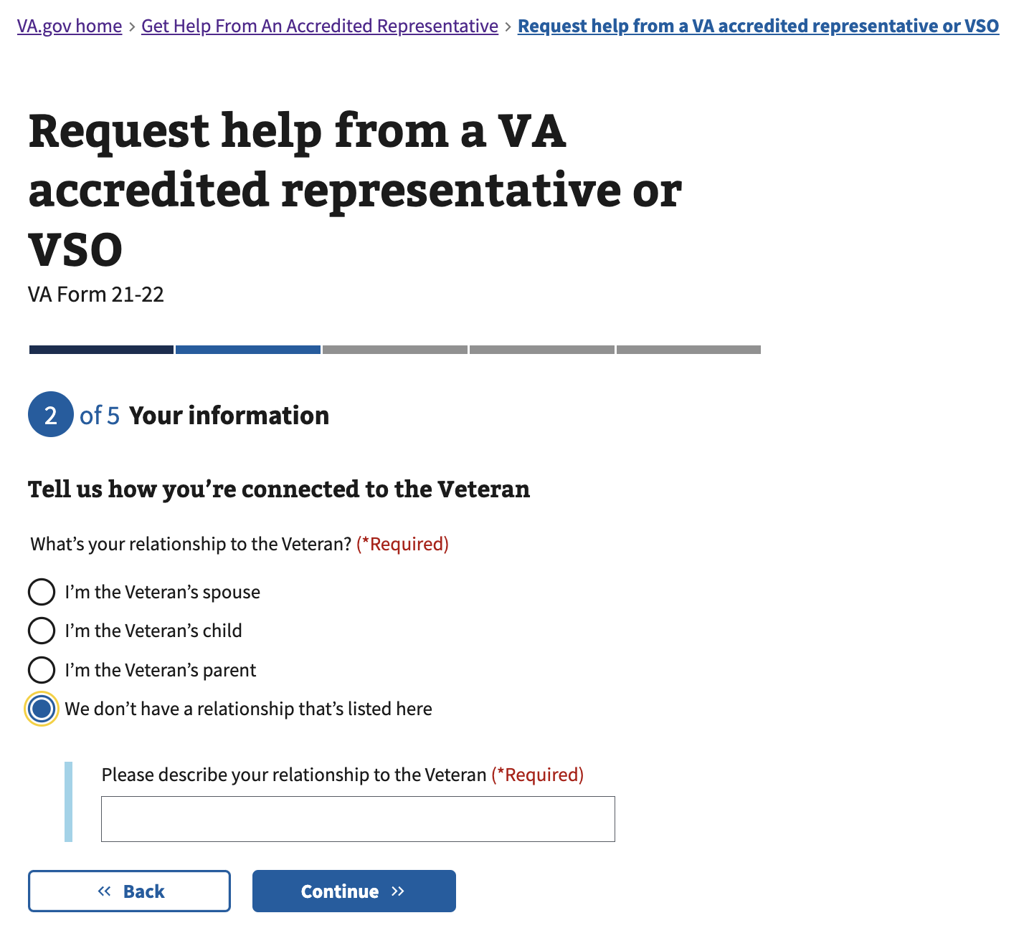

Figure 9: <https://www.va.gov/get-help-from-accredited-representative/appoint-rep/claimant-relationship>

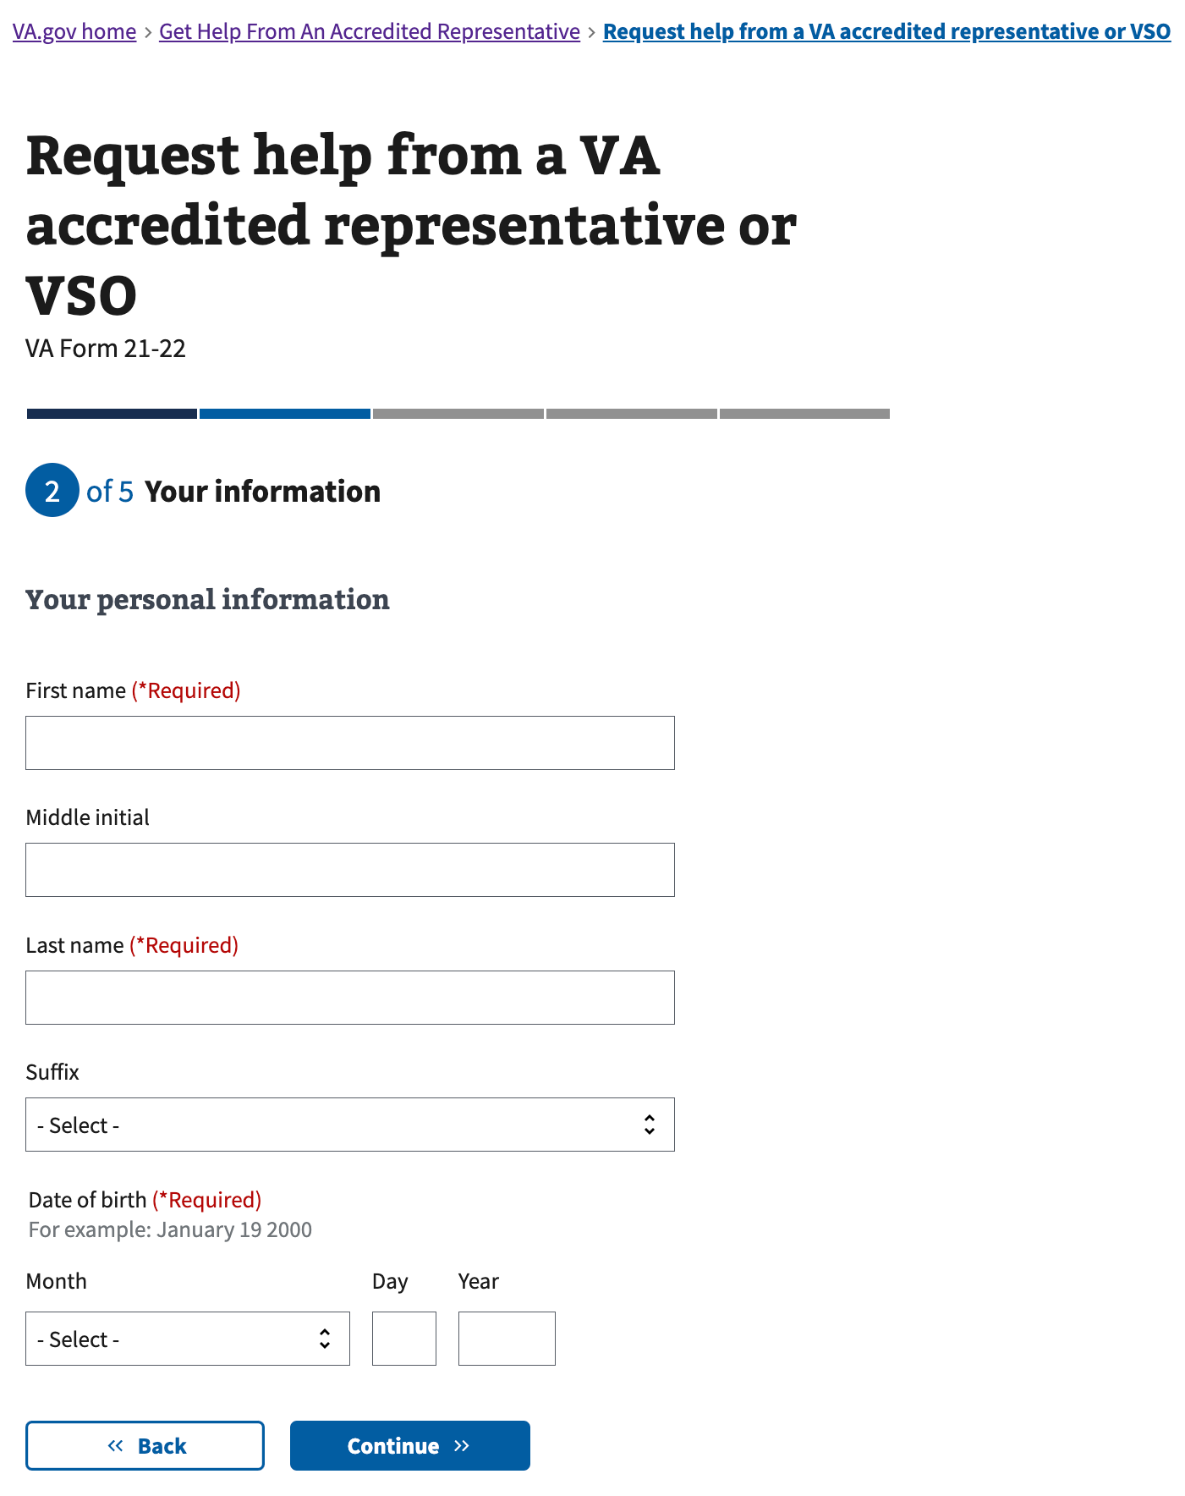

Figure 10: <https://www.va.gov/get-help-from-accredited-representative/appoint-rep/claimant-personal-information>

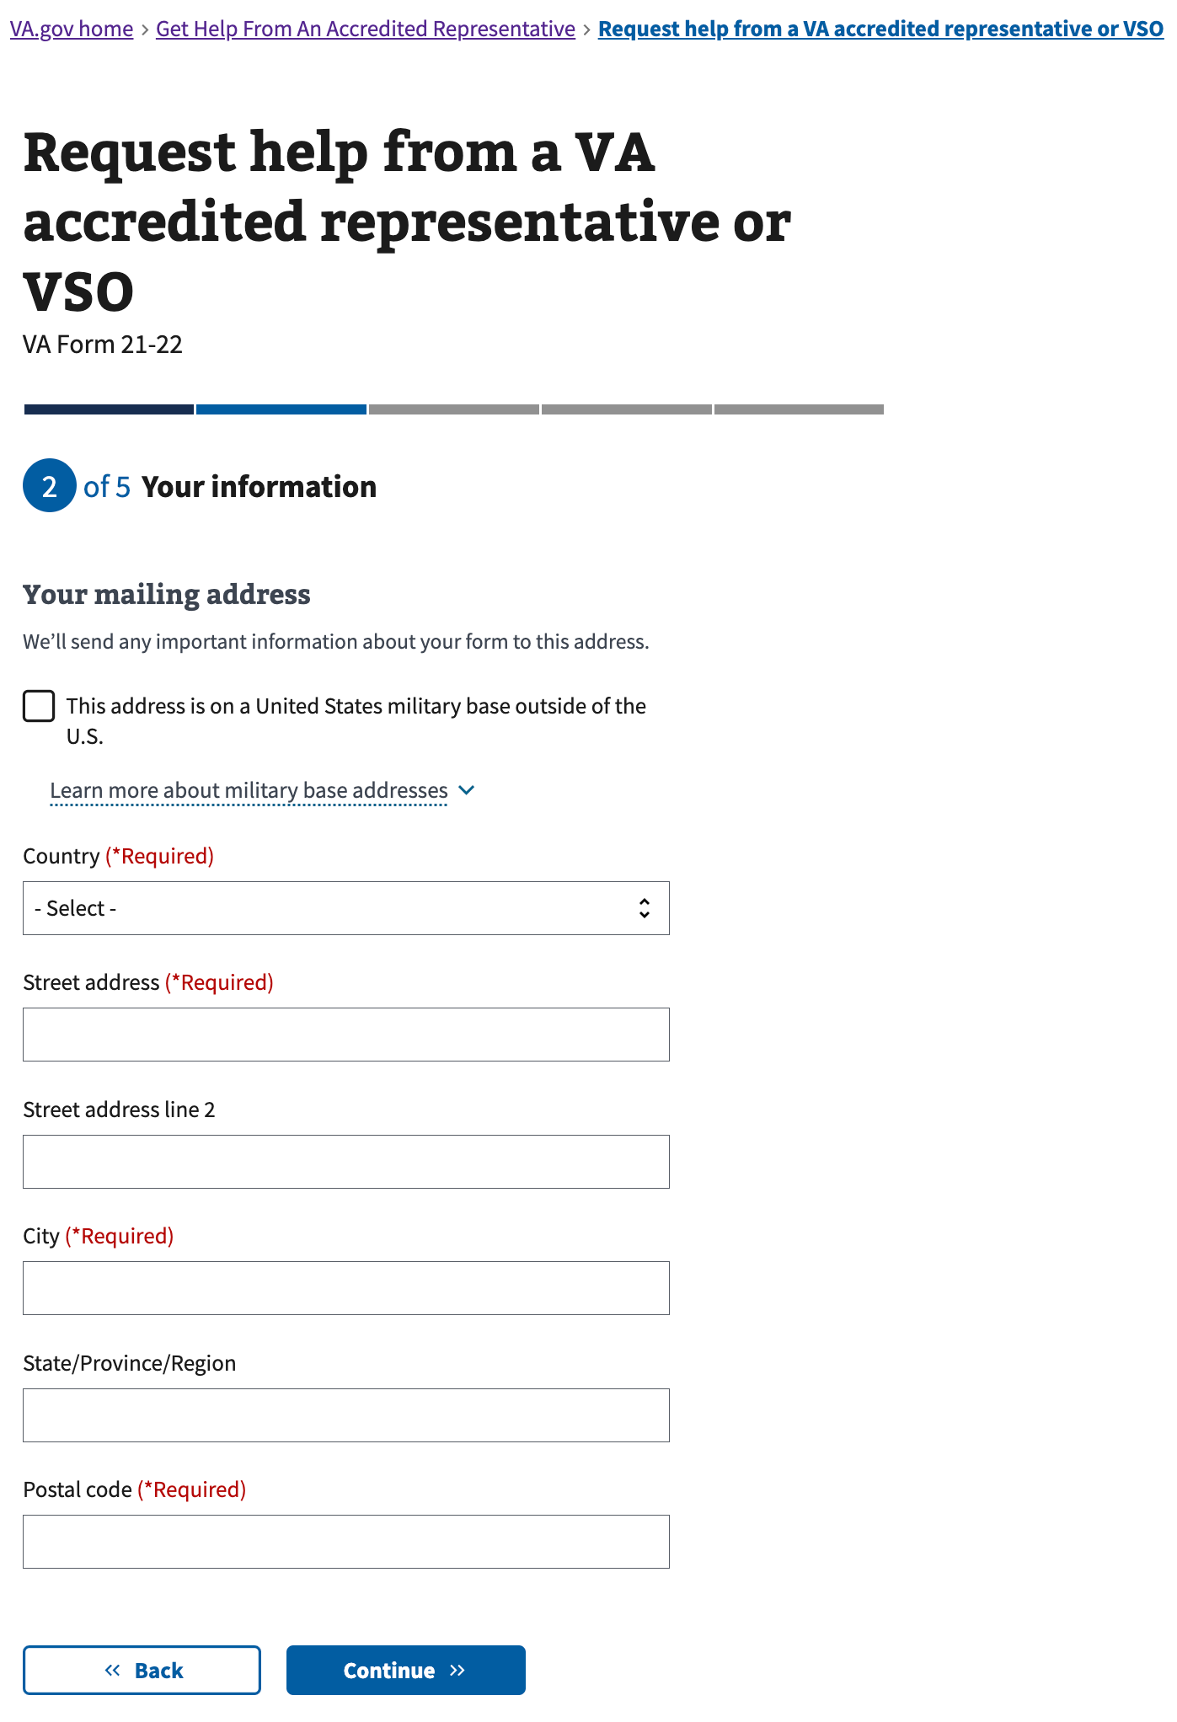

Figure 11: <https://www.va.gov/get-help-from-accredited-representative/appoint-rep/claimant-contact-mailing>

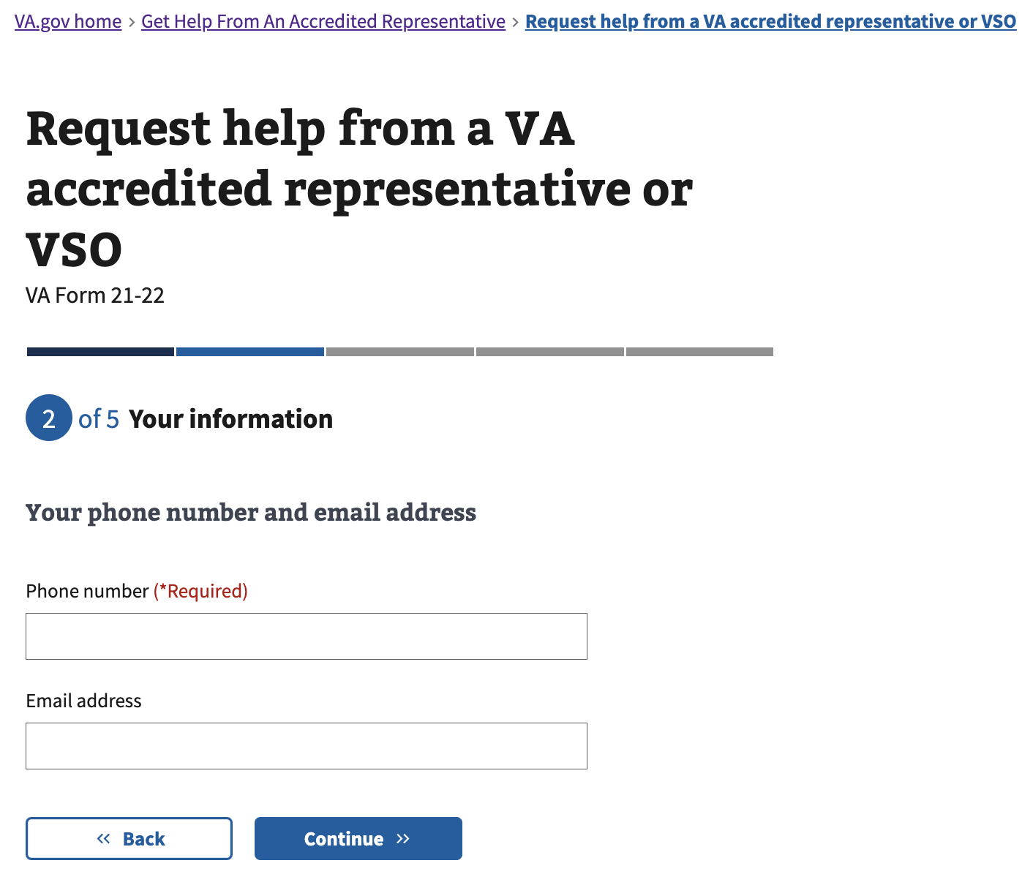

Figure 12: <https://www.va.gov/get-help-from-accredited-representative/appoint-rep/claimant-contact-phone-email>

### 4.5 Veteran Information

If the user indicated they are the Veteran, the experience will request their information at this time.

If the user indicated at the start of the experience that they are not the Veteran, the experience will now request the information of the Veteran they’re connected to. The screens below will instead read “Veteran information/mailing address/etc.” instead of “Your information/mailing address/etc.”.

The following Veteran Information screens show the **authenticated** experience, where users will have the inputs pre-populated based on information in their VA.gov Profile; changes will only affect this application and the VA.gov Profile will not be updated. (See the Claimant Information section above, for an example of content for unauthenticated users.)

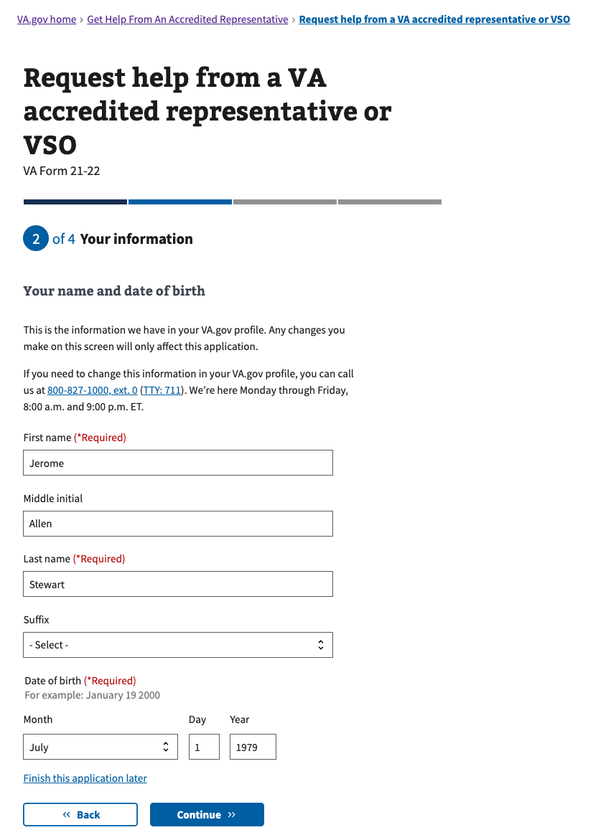

Figure 13 <https://www.va.gov/get-help-from-accredited-representative/appoint-rep/veteran-personal-information>

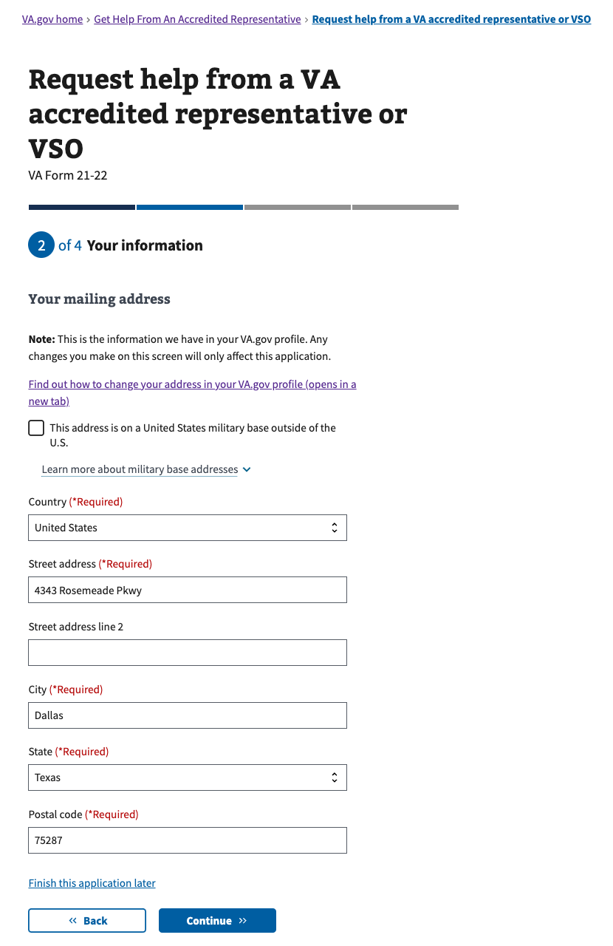

Figure 14 <https://www.va.gov/get-help-from-accredited-representative/appoint-rep/veteran-contact-mailing>

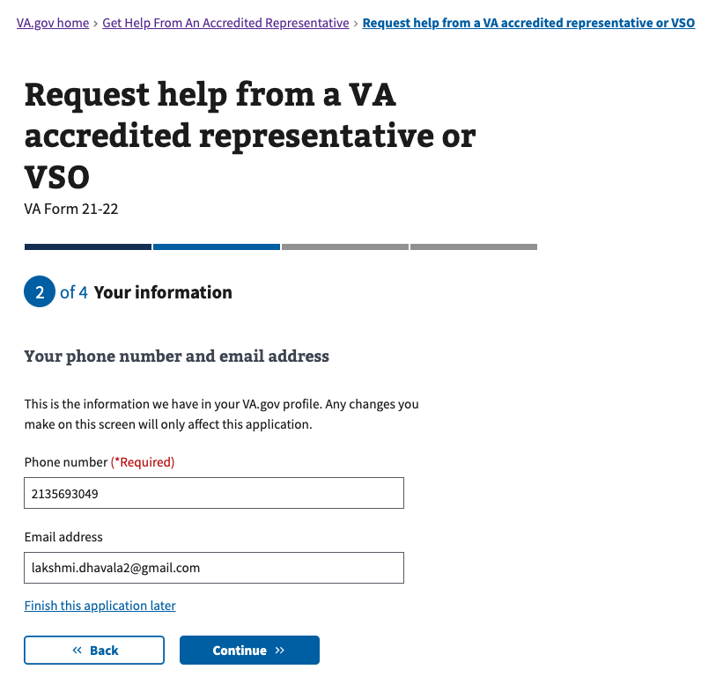

Figure 15 <https://www.va.gov/get-help-from-accredited-representative/appoint-rep/veteran-contact-phone-email>

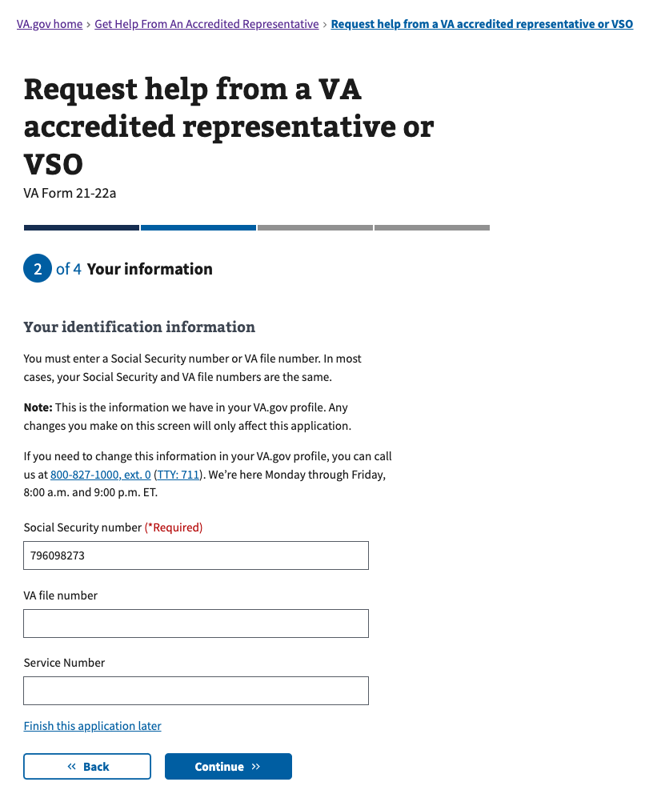

Figure 16: <https://www.va.gov/get-help-from-accredited-representative/appoint-rep/veteran-identification>

The following service information question is only relevant to VA Form 21-22a, so it will only come up when an accredited attorney or claims agent representative has been selected.

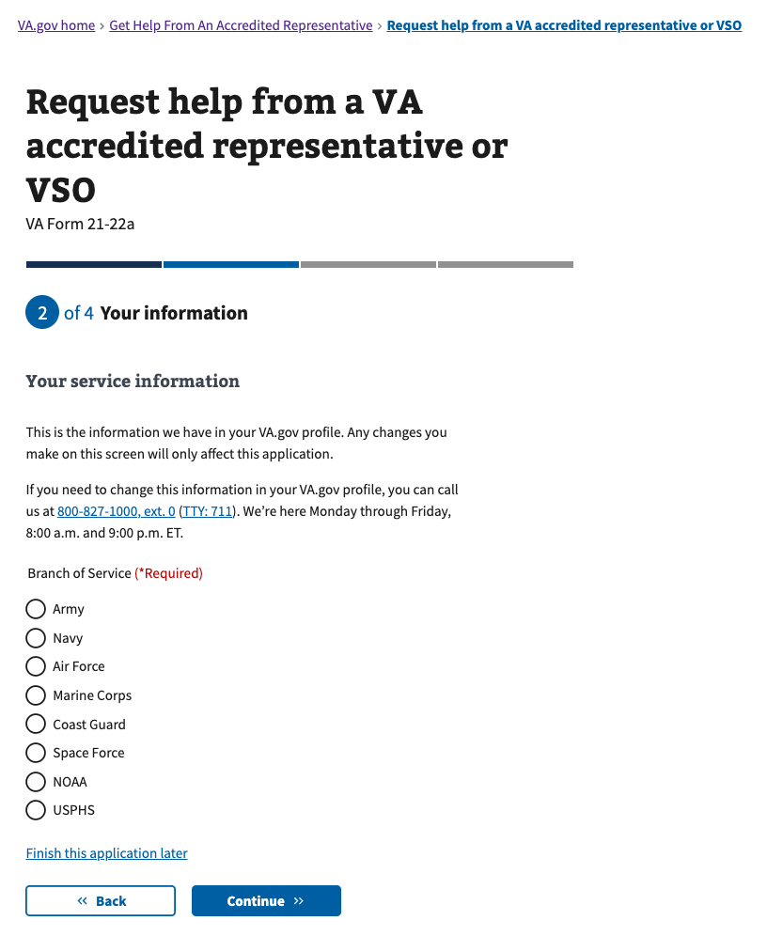

Figure 17: <https://www.va.gov/get-help-from-accredited-representative/appoint-rep/veteran-service-information>

### 4.6 Accredited representative authorizations

The user must provide authorization for the representative to access certain medical conditions. They can select all, none, or some (in which case they will be asked to specify on the next screen). These authorizations are not required, but may affect the accredited representative’s ability to help the Veteran or claimant.

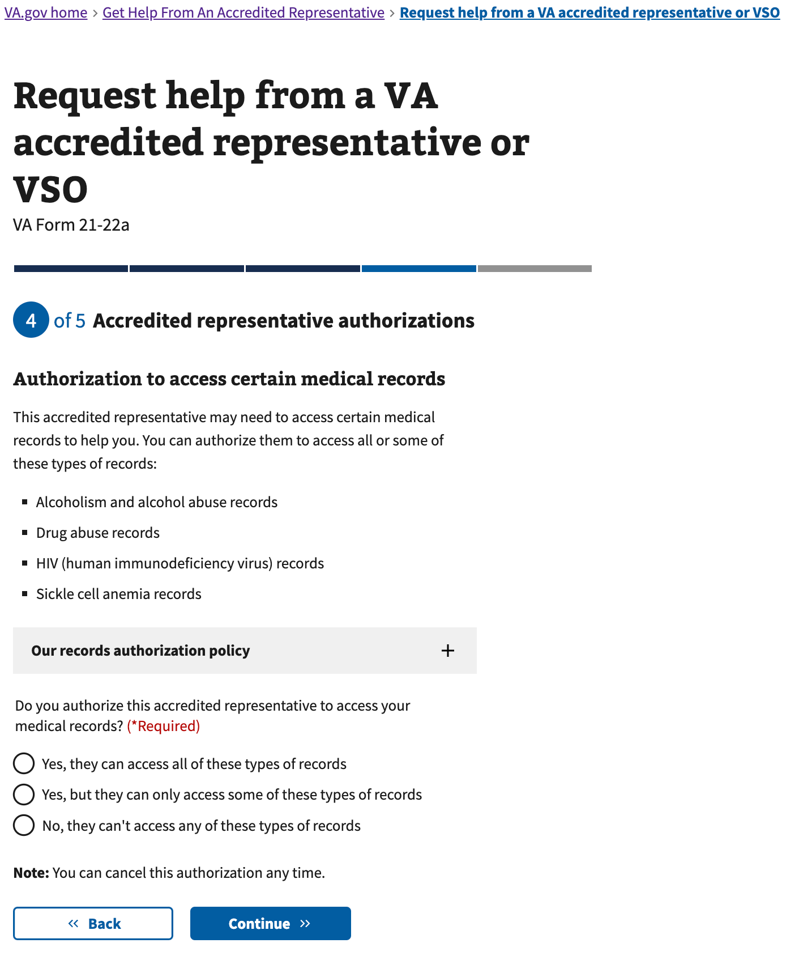

Figure 18: <https://www.va.gov/get-help-from-accredited-representative/appoint-rep/authorize-medical>

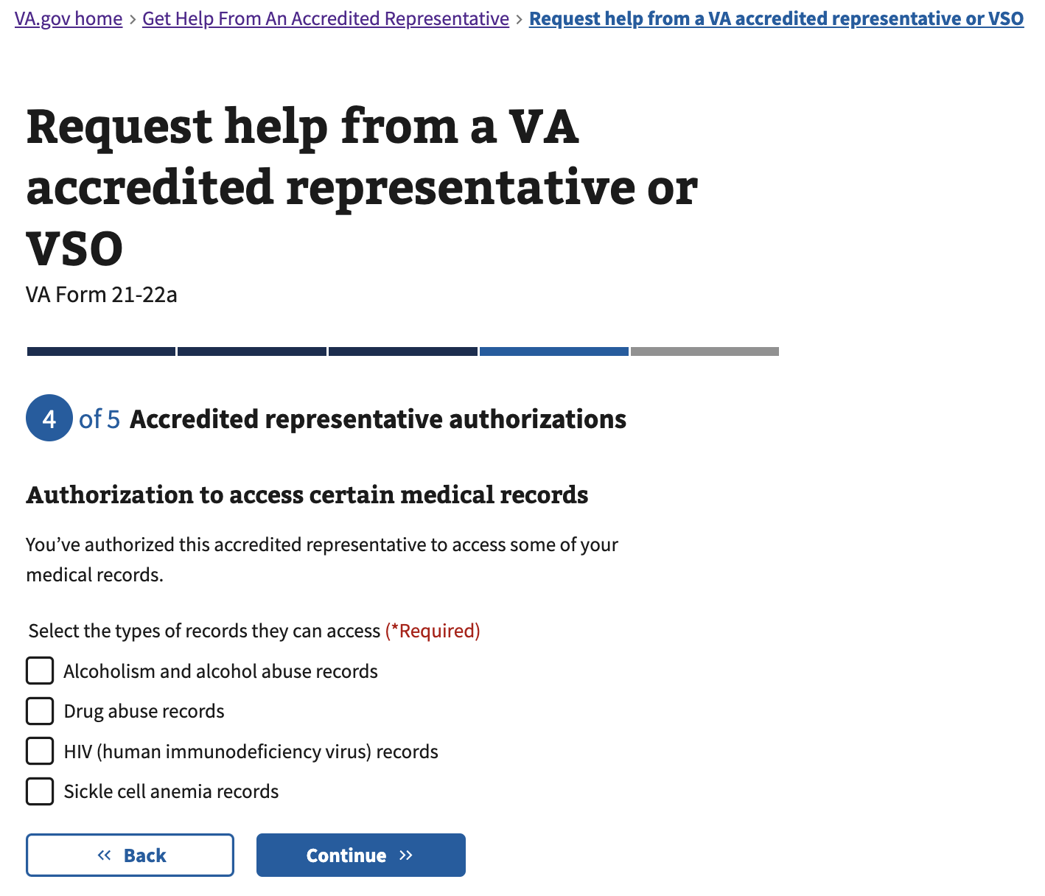

Figure 19: <https://www.va.gov/get-help-from-accredited-representative/appoint-rep/authorize-medical/select>

The user must provide authorization for the representative to change their address. This authorization is not required, but may affect the accredited representative’s ability to help the Veteran or claimant.

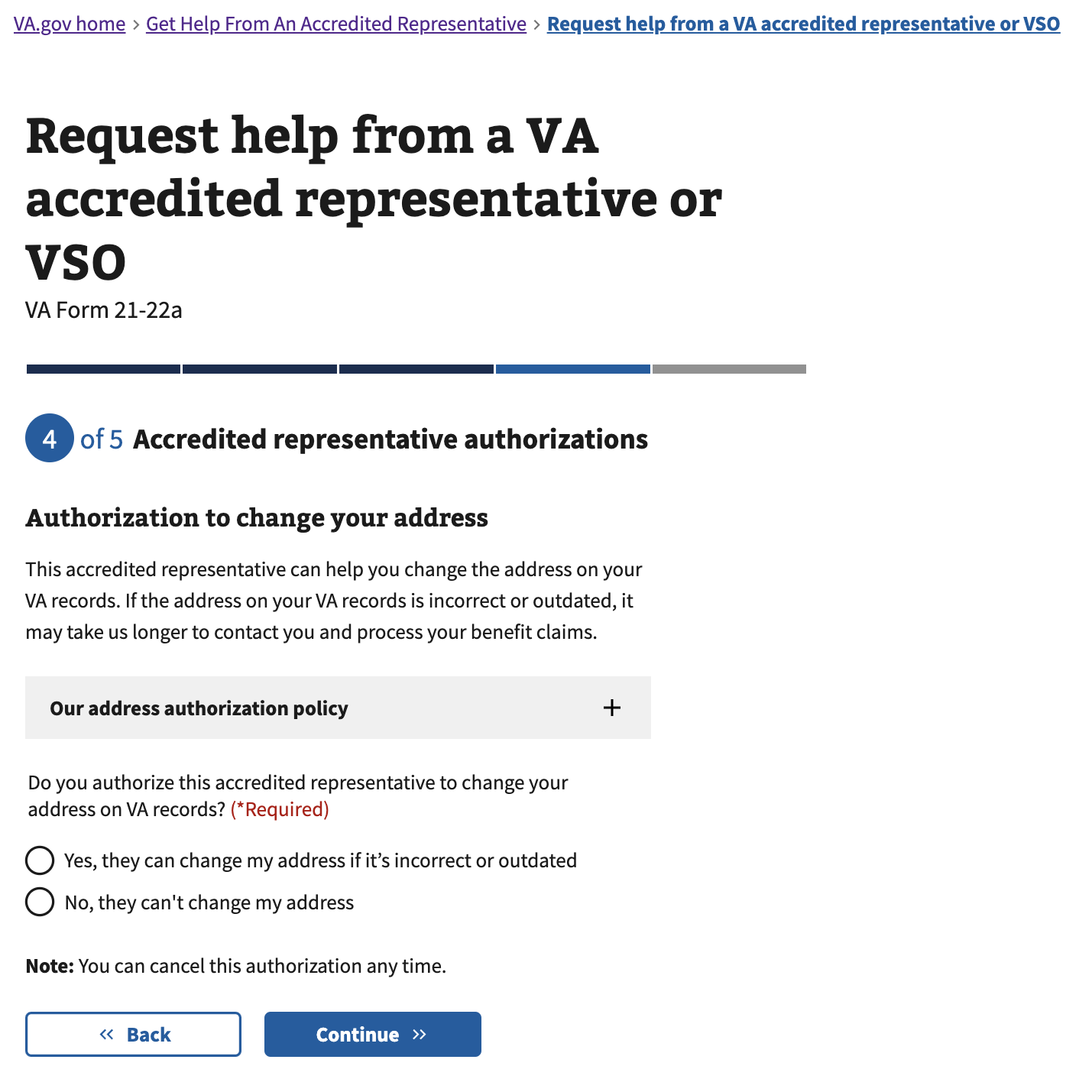

Figure 20: <https://www.va.gov/get-help-from-accredited-representative/appoint-rep/authorize-address>

For VA Form 21-22a for appointing an accredited attorney or claims agent, the user must provide authorization for the representative’s team to access their records within VA systems. This authorization is not required, but may affect the accredited representative’s ability to help the Veteran or claimant.

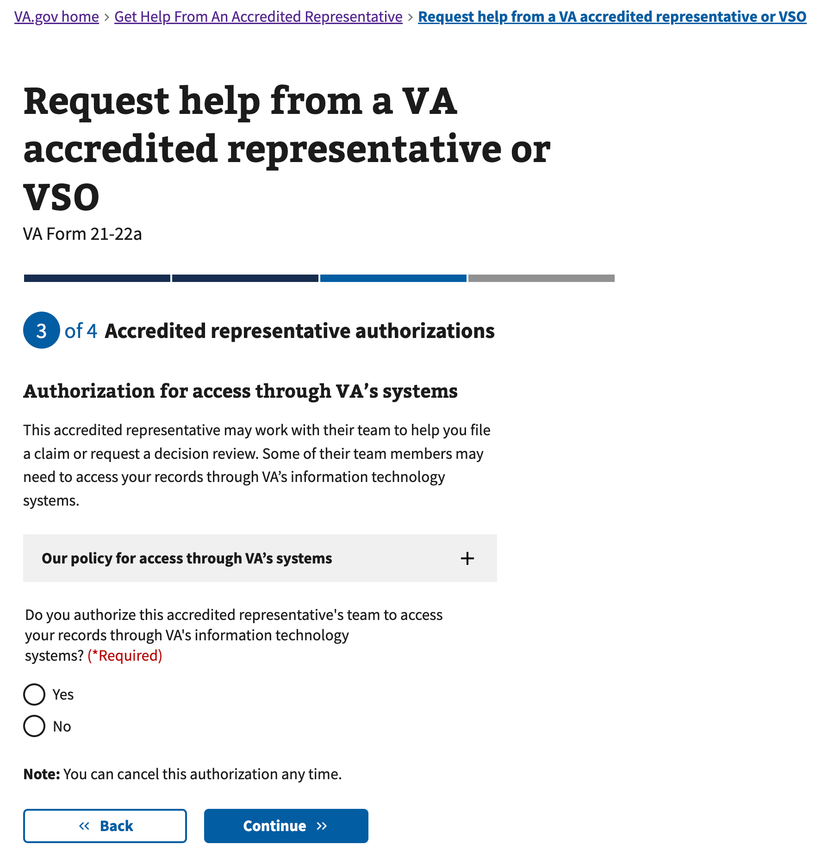

Figure 21: <https://www.va.gov/get-help-from-accredited-representative/appoint-rep/authorize-inside-va>

For VA Form 21-22a for appointing an accredited attorney or claims agent, the user must provide authorization for the representative’s team to access their records outside VA systems. If they allow this, they must specify by name which individuals are authorized. This authorization is not required, but may affect the accredited representative’s ability to help the Veteran or claimant.

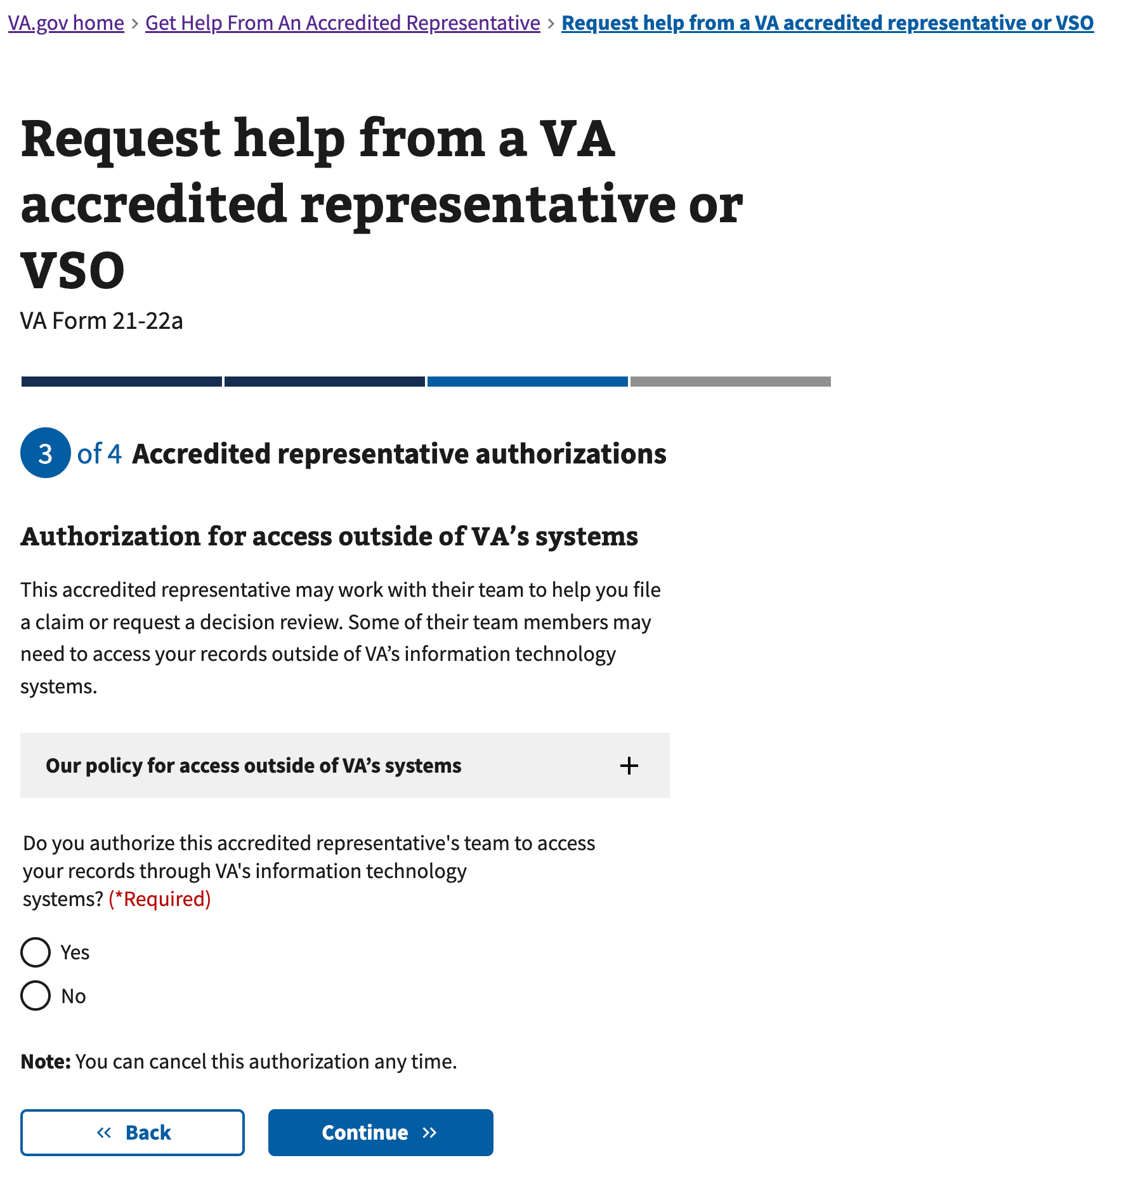

Figure 22: <https://www.va.gov/get-help-from-accredited-representative/appoint-rep/authorize-outside-va>

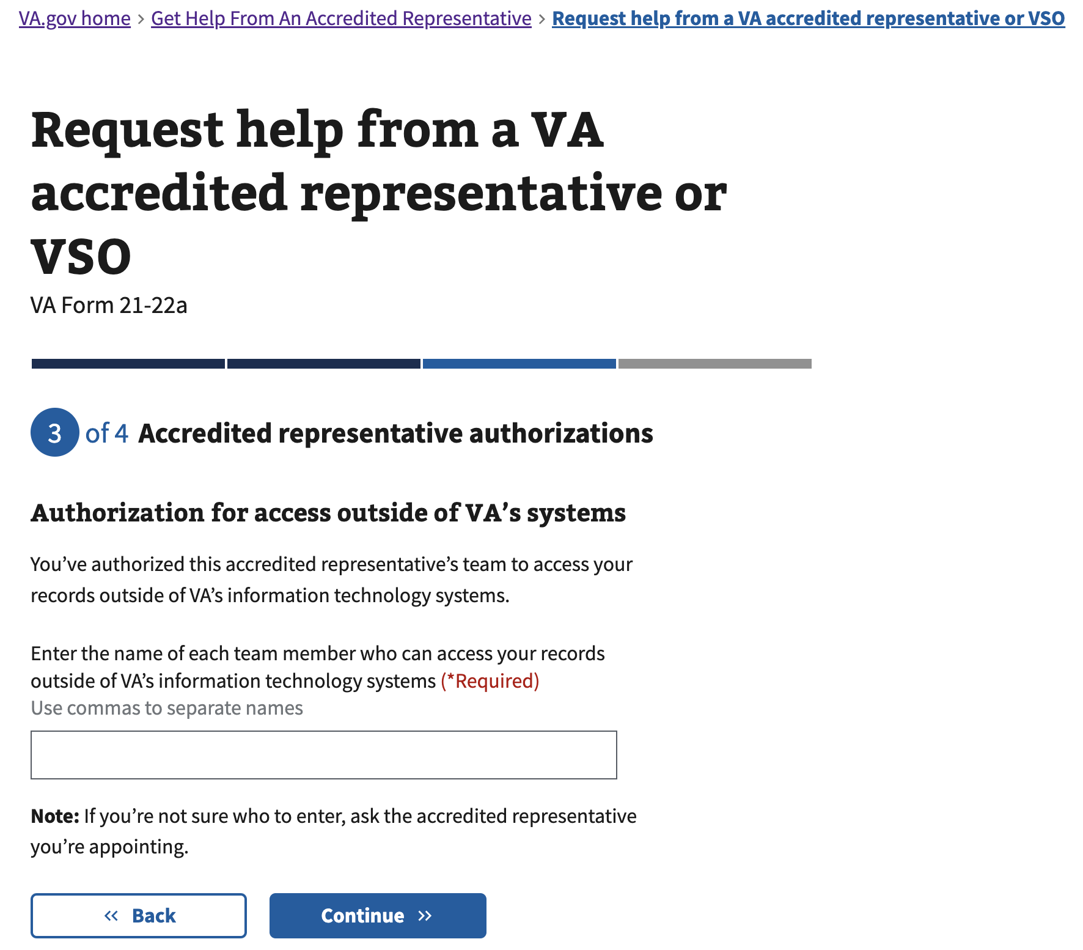

Figure 23: <https://www.va.gov/get-help-from-accredited-representative/appoint-rep/authorize-outside-va/names>

### 4.7 Review

The user will have an opportunity to review the information entered throughout this experience, as a final check before downloading their completed form on the next screen.

Most information can be edited directly in the expandable accordion component. The exception is the top “Accredited representative information” – if a user would like to change representatives at this time, they will be taken back into the form experience to the Accredited representative information section. If a user ends up selecting a new representative, they will need to step through the Appoint a Representative experience again to ensure all necessary information is captured.

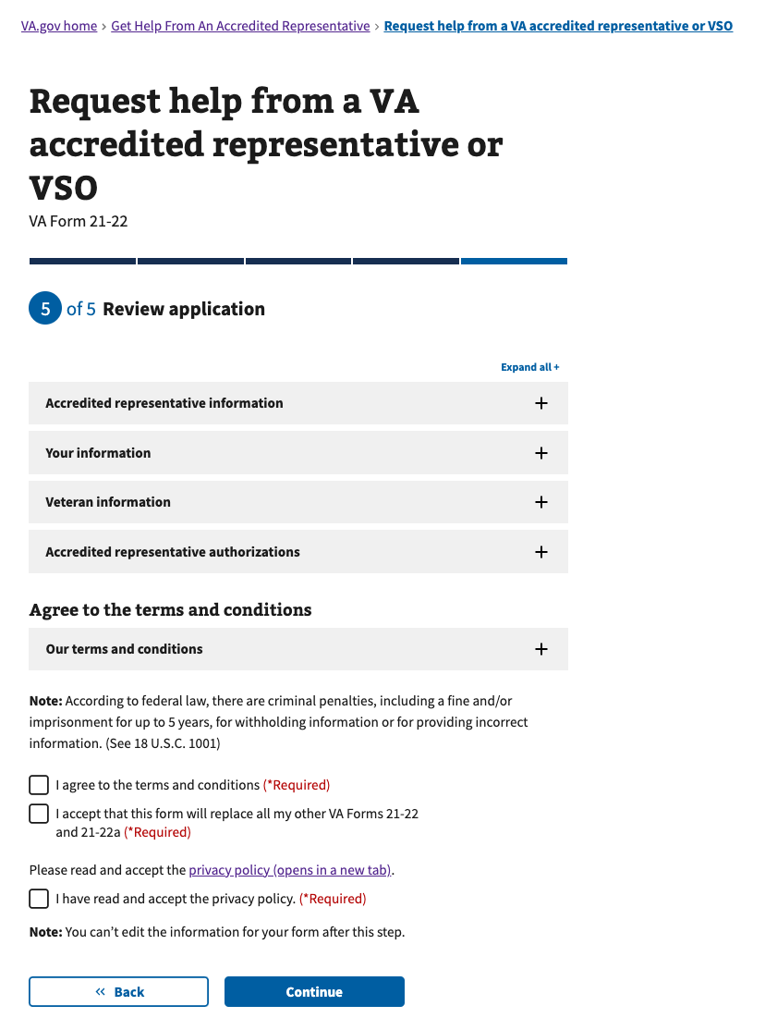

Figure 24: <https://www.va.gov/get-help-from-accredited-representative/appoint-rep/review>

### 4.8 PDF Generation Pathway: Download (Confirmation) + Next Steps

For users ending in PDF generation, after continuing on from the Review page the completed form is made available for download. Users **must** confirm they have downloaded their form before proceeding, as the form is critical for completing the next steps to appoint the representative.

Once a user leaves this page, they will not be able to get back here. If a user needed to re-download a pre-filled form, they would need to step through the Appoint a Representative experience to generate a new form to download.

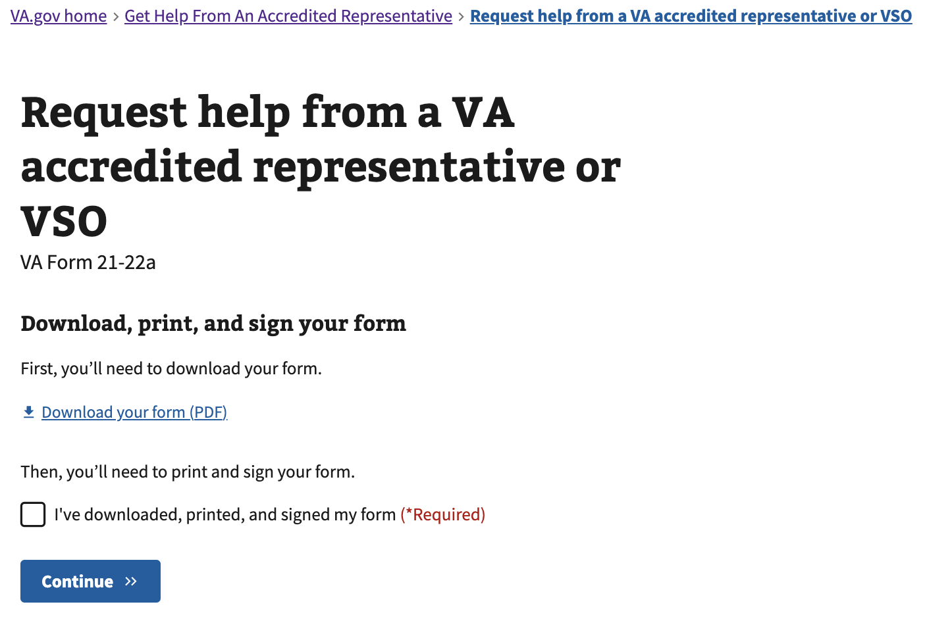

Figure 25: <https://www.va.gov/get-help-from-accredited-representative/appoint-rep/confirmation> (PDF Generation)

After downloading the form, on the following “Next Steps” page the user is given guidance on what to do next with the form they’ve just downloaded. Next steps are also communicated in an email notification from “U.S. Department of Veterans Affairs” with the subject “What to do next to appoint an accredited representative”.

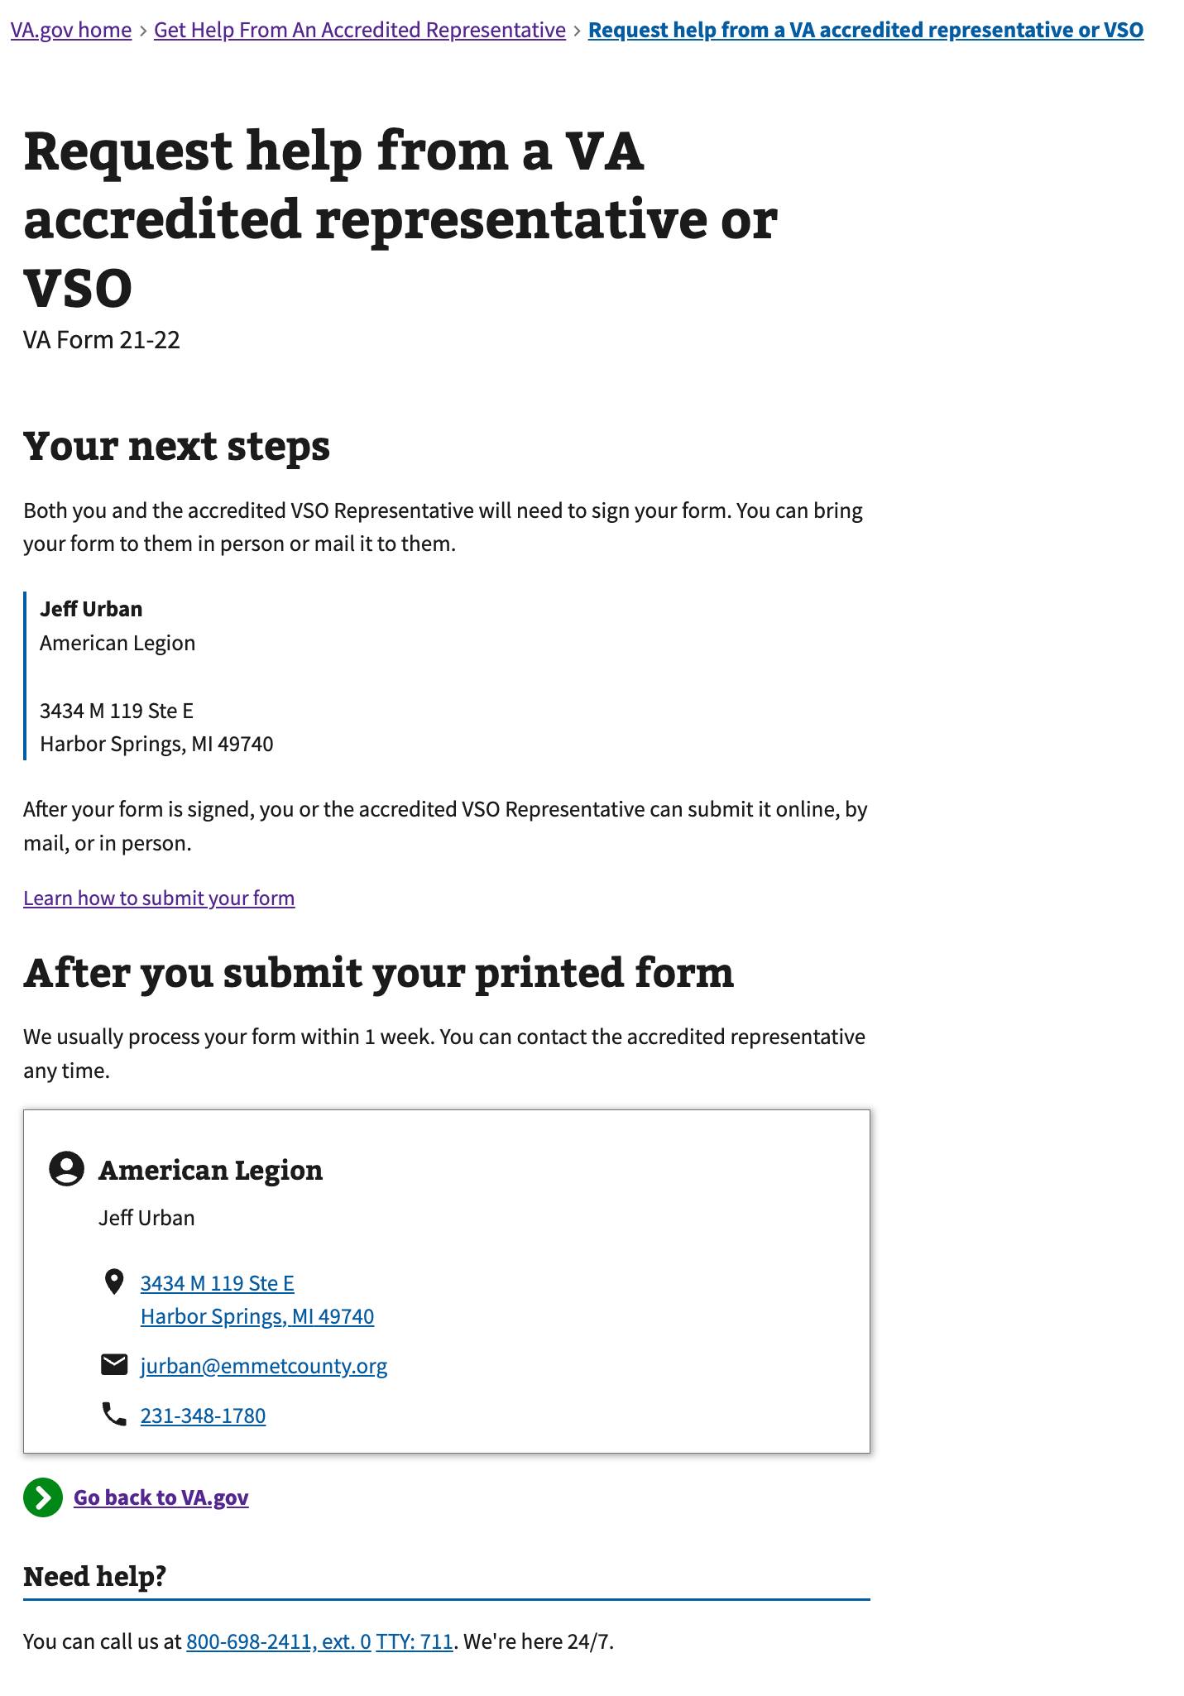

Figure 26: <https://www.va.gov/get-help-from-accredited-representative/appoint-rep/next-steps> (PDF Generation)

### 4.9 Online Submission Pathway: Confirmation

For users ending in online submission, after continuing on from the Review page the 21-22 form is submitted digitally to the representative for accepting or declining in the Accredited Representative Portal. The Veteran will receive an email notification with the representative’s decision.

If the representative does not respond immediately, the online request remains active for 60 days after submission, and the Veteran will receive email notifications on Day 30 (expiration warning) and Day 60 (expiration confirmation) if the representative does not respond to the request.

Users will have the option to save a copy of their form or print the confirmation page for their records.

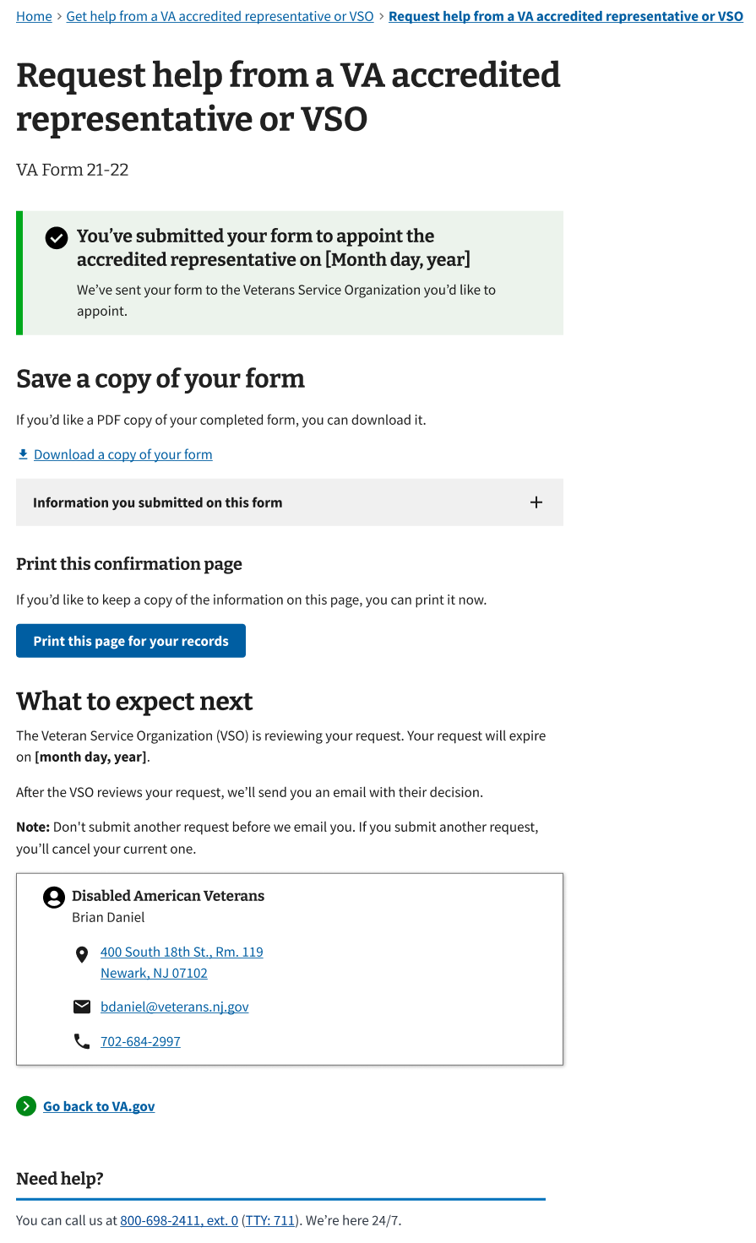

Figure 27: <https://www.va.gov/get-help-from-accredited-representative/appoint-rep/confirmation> (Online Submission)

## 5. Major Issues and Error Messages

In the form-fill experience, there will be standard validation alerts to enforce required fields and accurate formatting for inputs such as birth date, phone number and social security number. There are also custom error messages specific to Appoint a Representative, which are detailed below.

### 5.1 Accredited representative information

If a user **does not search for a representative** and tries to “Continue”, they will see this error:

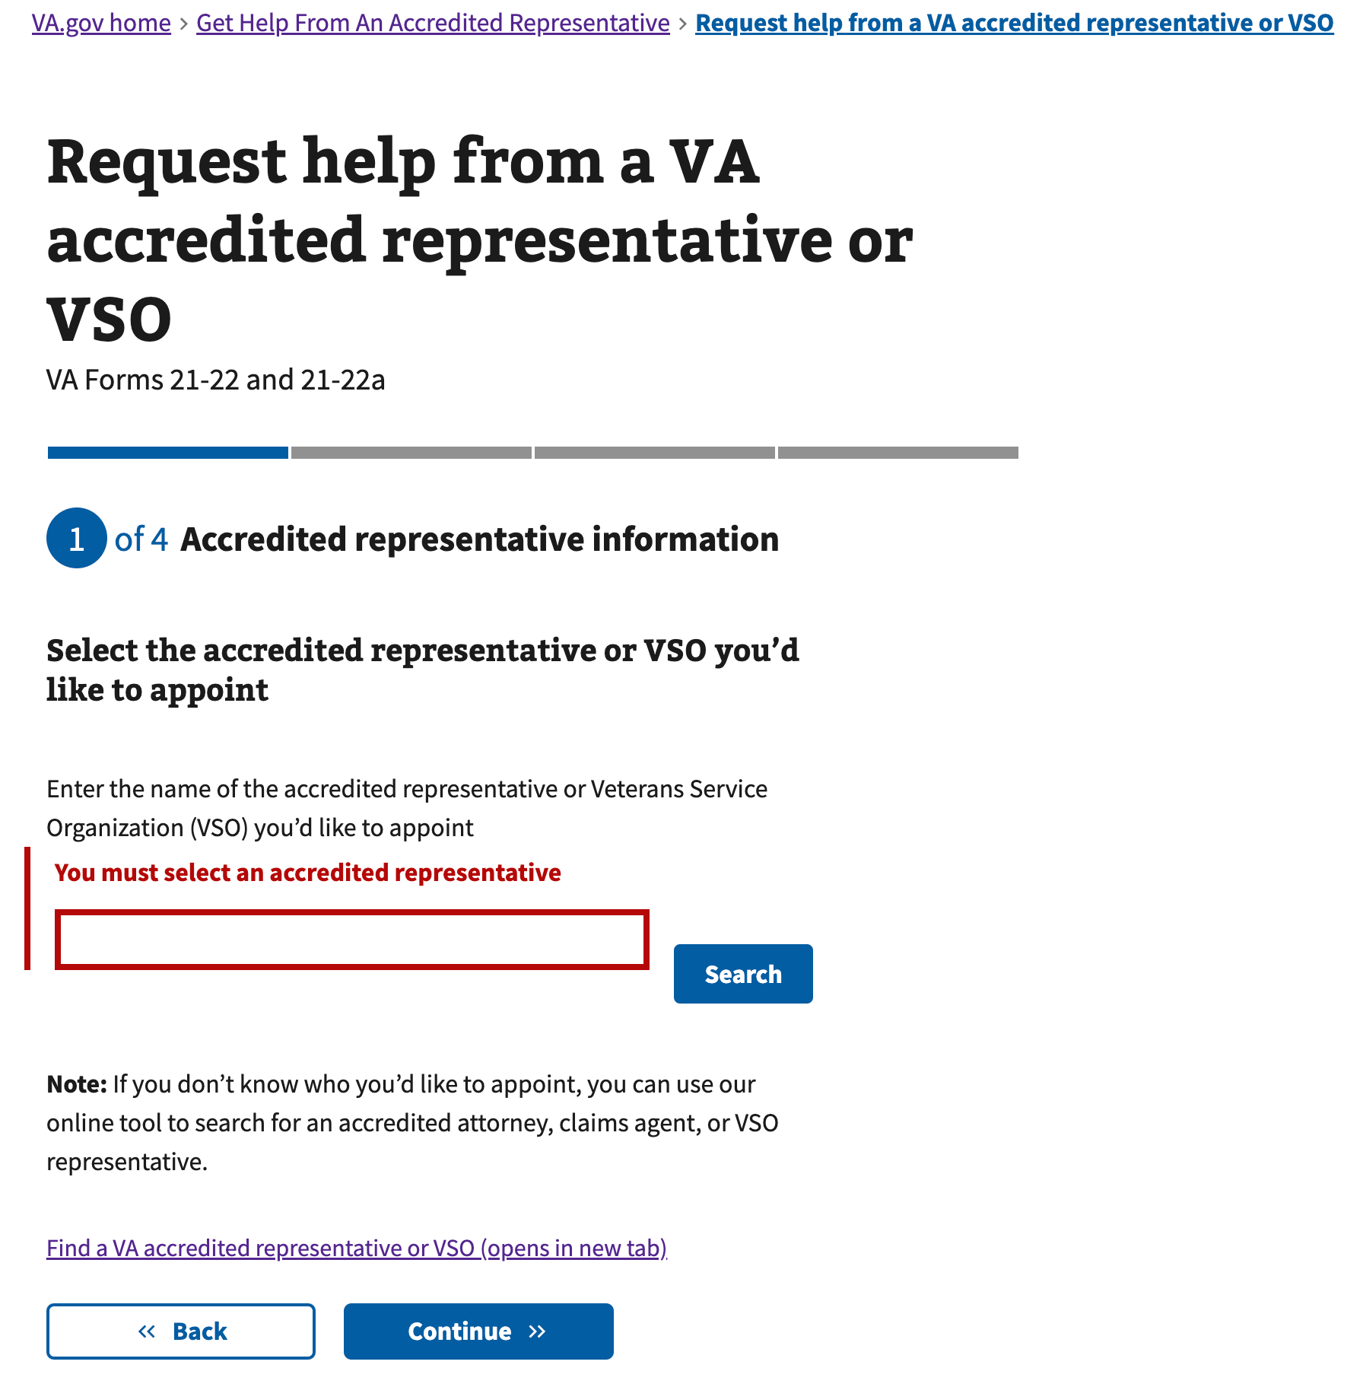

Figure 28: <https://www.va.gov/get-help-from-accredited-representative/appoint-rep/representative-select> (Search Error)

If a user searches for a representative, but **does not select a representative** and instead tries to “Continue”, they will see this error:

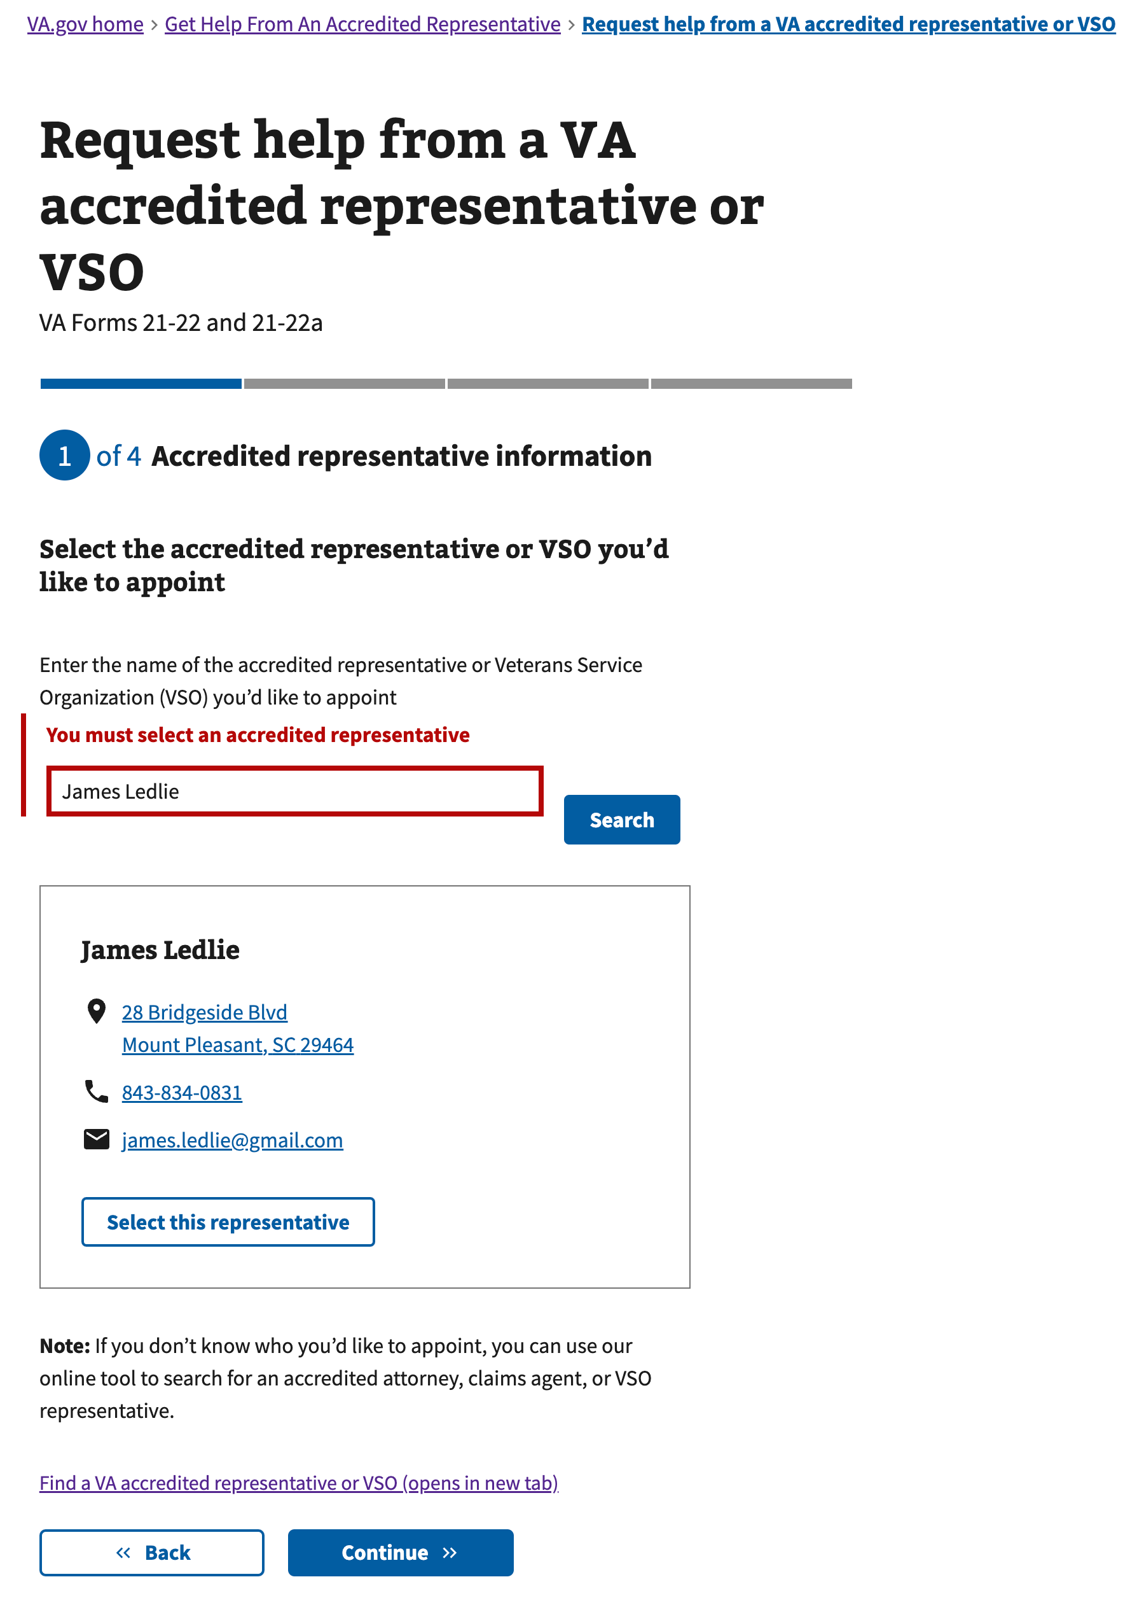

Figure 29: <https://www.va.gov/get-help-from-accredited-representative/appoint-rep/representative-select> (Select Error)

### 5.2 Review

If **there is an issue advancing from the Review page (due to the online submission or PDF generation failing)**, users will see this error:

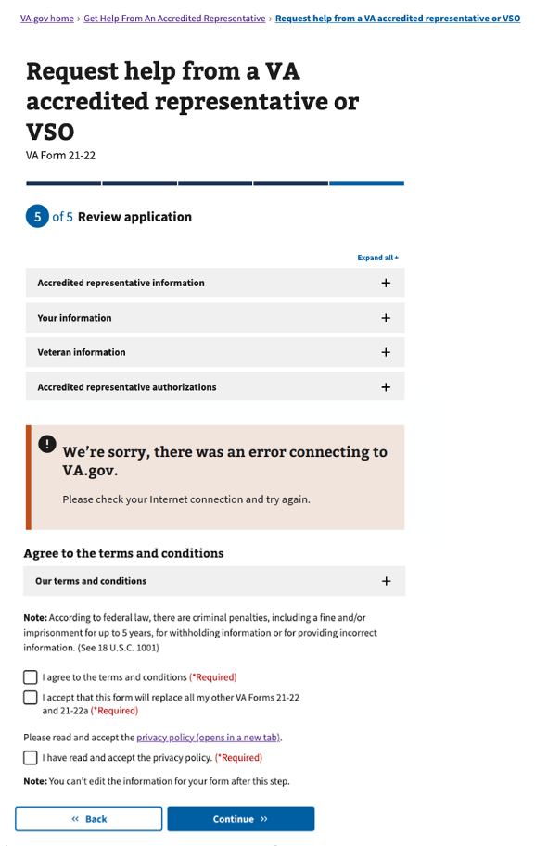

Figure 30: <https://www.va.gov/get-help-from-accredited-representative/appoint-rep/review> (PDF Generation Error)

**Table of Figures**

Figure 1: https://www.va.gov/get-help-from-accredited-representative/appoint-rep/introduction (unauthenticated) 6

Figure 2 https://www.va.gov/get-help-from-accredited-representative/appoint-rep/introduction (authenticated) 7

Figure 3: https://www.va.gov/get-help-from-accredited-representative/appoint-rep/claimant-type 8

Figure 4: https://www.va.gov/get-help-from-accredited-representative/appoint-rep/representative-select 8

Figure 5: https://www.va.gov/get-help-from-accredited-representative/appoint-rep/representative-contact 9

Figure 6: https://www.va.gov/get-help-from-accredited-representative/appoint-rep/representative-submission-method 9

Figure 7: https://www.va.gov/get-help-from-accredited-representative/appoint-rep/representative-organization 10

Figure 8: https://www.va.gov/get-help-from-accredited-representative/appoint-rep/representative-replace 11

Figure 9: https://www.va.gov/get-help-from-accredited-representative/appoint-rep/claimant-relationship 12

Figure 10: https://www.va.gov/get-help-from-accredited-representative/appoint-rep/claimant-personal-information 12

Figure 11: https://www.va.gov/get-help-from-accredited-representative/appoint-rep/claimant-contact-mailing 13

Figure 12: https://www.va.gov/get-help-from-accredited-representative/appoint-rep/claimant-contact-phone-email 13

Figure 13 https://www.va.gov/get-help-from-accredited-representative/appoint-rep/veteran-personal-information 14

Figure 14 https://www.va.gov/get-help-from-accredited-representative/appoint-rep/veteran-contact-mailing 15

Figure 15 https://www.va.gov/get-help-from-accredited-representative/appoint-rep/veteran-contact-phone-email 15

Figure 16: https://www.va.gov/get-help-from-accredited-representative/appoint-rep/veteran-identification 16

Figure 17: https://www.va.gov/get-help-from-accredited-representative/appoint-rep/veteran-service-information 16

Figure 18: https://www.va.gov/get-help-from-accredited-representative/appoint-rep/authorize-medical 17

Figure 19: https://www.va.gov/get-help-from-accredited-representative/appoint-rep/authorize-medical/select 17

Figure 20: https://www.va.gov/get-help-from-accredited-representative/appoint-rep/authorize-address 18

Figure 21: https://www.va.gov/get-help-from-accredited-representative/appoint-rep/authorize-inside-va 18

Figure 22: https://www.va.gov/get-help-from-accredited-representative/appoint-rep/authorize-outside-va 19

Figure 23: https://www.va.gov/get-help-from-accredited-representative/appoint-rep/authorize-outside-va/names 19

Figure 24: https://www.va.gov/get-help-from-accredited-representative/appoint-rep/review 20

Figure 25: https://www.va.gov/get-help-from-accredited-representative/appoint-rep/confirmation 21

Figure 26: https://www.va.gov/get-help-from-accredited-representative/appoint-rep/next-steps 22

Figure 27: https://www.va.gov/get-help-from-accredited-representative/appoint-rep/representative-select (Search Error) 23

Figure 28: https://www.va.gov/get-help-from-accredited-representative/appoint-rep/representative-select (Select Error) 23

Figure 29: https://www.va.gov/get-help-from-accredited-representative/appoint-rep/review (PDF Generation Error) 24